

ALTA 11 Mortgage Modification Endorsement (07-01-2021)
THIS ENDORSEMENT IS ISSUED AS PART OF POLICY NUMBER

ISSUED BY
STEWART TITLE GUARANTY COMPANY

File No.: | Charge:

1. The Company insures against loss or damage sustained by the Insured by reason of:
a. The invalidity or unenforceability of the lien of the Insured Mortgage upon the Title at the Date of Endorsement as a result of the agreement dated , recorded (“Modification”); and
b. The lack of priority of the lien of the Insured Mortgage, at the Date of Endorsement, over defects in or liens or encumbrances on the Title, except for those shown in the policy or any prior endorsement and except:

2. This endorsement does not insure against loss or damage, and the Company will not pay costs, attorneys’ fees, or expenses, by reason of any claim that arises out of the transaction creating the Modification by reason of the operation of federal bankruptcy, state insolvency, or similar creditors’ rights law that is based on the Modification being a:
a. fraudulent conveyance or fraudulent transfer;
b. voidable transfer under the Uniform Voidable Transactions Act; or
c. preferential transfer to the extent the Modification is not a transfer made as a contemporaneous exchange for new value or for any other reason unless the preferential transfer results solely from the failure:
i. to timely record the Modification in the Public Records after execution and delivery of the Modification to the Insured; or
ii. of the recording of the Modification in the Public Records to impart notice of its existence to a purchaser for value or to a judgment or lien creditor.

This endorsement is issued as part of the policy. Except as it expressly states, it does not (i) modify any of the terms and provisions of the policy, (ii) modify any prior endorsements, (iii) extend the Date of Policy, or (iv) increase the Amount of Insurance. To the extent a provision of the policy or a previous endorsement is inconsistent with an express provision of this endorsement, this endorsement controls. Otherwise, this endorsement is subject to all of the terms and provisions of the policy and of any prior endorsements.

Date: _____________________

 |  | 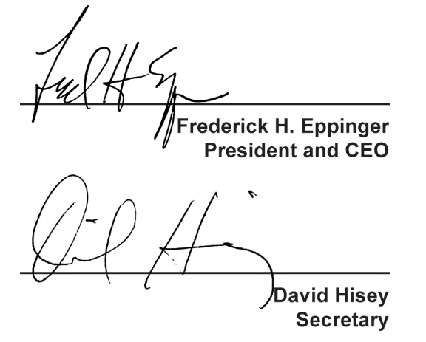
  Countersigned by:
  _______________________________
  Authorized Countersignature

