

ALTA ENDORSEMENT 28-06 (EASEMENT-DAMAGE OR ENFORCED REMOVAL)
ATTACHED TO POLICY NUMBER

ISSUED BY
STEWART TITLE GUARANTY COMPANY

File No.: | Charge:

The Company insures against loss or damage sustained by the Insured if the exercise of the granted or reserved rights to use or maintain the easement(s) referred to in Exception(s) of Schedule B results in:
(1) damage to an existing building located on the Land, or
(2) enforced removal or alteration of an existing building located on the Land.
This endorsement is issued as part of the policy. Except as it expressly states, it does not (i) modify any of the terms and provisions of the policy, (ii) modify any prior endorsements, (iii) extend the Date of Policy, or (iv) increase the Amount of Insurance. To the extent a provision of the policy or a previous endorsement is inconsistent with an express provision of this endorsement, this endorsement controls. Otherwise, this endorsement is subject to all of the terms and provisions of the policy and of any prior endorsements.

Date:

 |  | 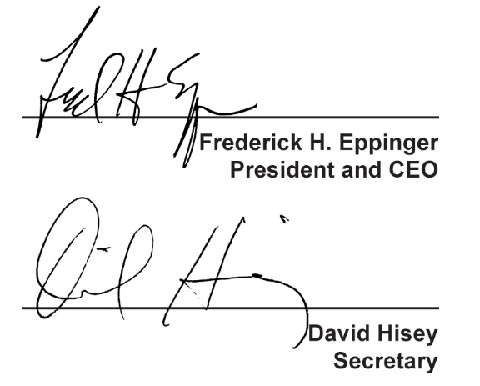
  Countersigned by:
  ___________________________________
  Authorized Countersignature

