

ALTA ENDORSEMENT 34-06 (IDENTIFIED RISK COVERAGE)
ATTACHED TO POLICY NUMBER ______________________

ISSUED BY
STEWART TITLE GUARANTY COMPANY

File No.: ______________________ | Charge: ______________________

- As used in this endorsement "Identified Risk" means ______________________ described in Exception ______________________ of Schedule B.
- The Company insures against loss or damage sustained by the Insured by reason of:
  - A final order or decree enforcing the Identified Risk in favor of an adverse party; or
  - The release of a prospective purchaser or lessee of the Title or lender on the Title from the obligation to purchase, lease or lend as a result of the Identified Risk, but only if
    - there is a contractual condition requiring the delivery of marketable title, and
    - neither the Company nor any other title insurance company is willing to insure over the Identified Risk with the same conditions as in this endorsement.
- The Company will also pay the costs, attorneys' fees, and expenses incurred in defense of the Title by reason of the Identified Risk insured against by Paragraph 2 of this endorsement, but only to the extent provided in the Conditions.
- This endorsement does not obligate the Company to establish the Title free of the Identified Risk or to remove the Identified Risk, but if the Company does establish the Title free of the Identified Risk or removes it, Section 9(a) of the Conditions applies.

This endorsement is issued as part of the policy. Except as it expressly states, it does not (i) modify any of the terms and provisions of the policy, (ii) modify any prior endorsements, (iii) extend the Date of Policy, or (iv) increase the Amount of Insurance. To the extent a provision of the policy or a previous endorsement is inconsistent with an express provision of this endorsement, this endorsement controls. Otherwise, this endorsement is subject to all of the terms and provisions of the policy and of any prior endorsements.

Date: _____________________

 |  | 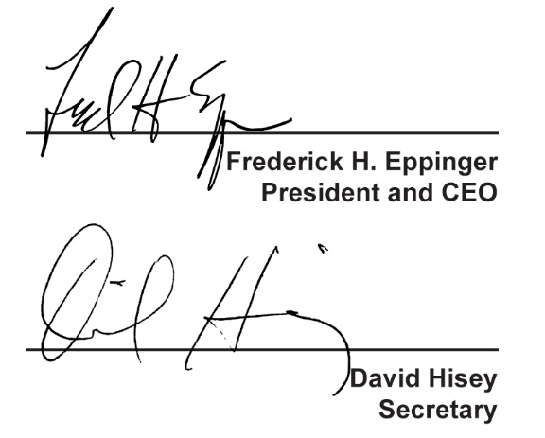
  Countersigned by:
  ___________________________________
  Authorized Countersignature

