

ALTA ENDORSEMENT 35-06 (MINERALS AND OTHER SUBSURFACE SUBSTANCES-BUILDINGS)
ATTACHED TO POLICY NUMBER

ISSUED BY
STEWART TITLE GUARANTY COMPANY

File No.: | Charge:

- The insurance provided by this endorsement is subject to the exclusion in Section 4 of this endorsement; and the Exclusions from Coverage, the Exceptions from Coverage contained in Schedule B, and the Conditions in the policy.
- For purposes of this endorsement only, "Improvement" means a building on the Land at Date of Policy.
- The Company insures against loss or damage sustained by the Insured by reason of the enforced removal or alteration of any Improvement, resulting from the future exercise of any right existing at Date of Policy to use the surface of the Land for the extraction or development of minerals or any other subsurface substances excepted from the description of the Land or excepted in Schedule B.
- This endorsement does not insure against loss or damage (and the Company will not pay costs, attorneys' fees or expenses) resulting from:
  - contamination, explosion, fire, flooding, vibration, fracturing, earthquake or subsidence; or
  - negligence by a person or an Entity exercising a right to extract or develop minerals or other subsurface substances; or
  - the exercise of the rights described in .

This endorsement is issued as part of the policy. Except as it expressly states, it does not (i) modify any of the terms and provisions of the policy, (ii) modify any prior endorsements, (iii) extend the Date of Policy, or (iv) increase the Amount of Insurance. To the extent a provision of the policy or a previous endorsement is inconsistent with an express provision of this endorsement, this endorsement controls. Otherwise, this endorsement is subject to all of the terms and provisions of the policy and of any prior endorsements.

Date:

 |  | 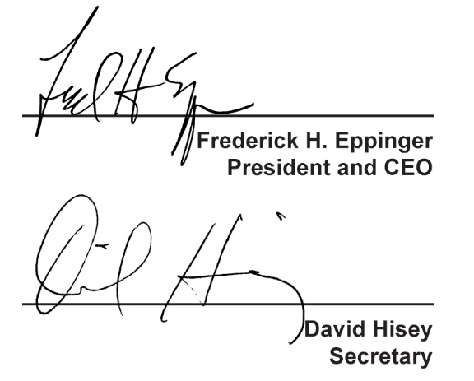
  Countersigned by:
  ___________________________________
  Authorized Countersignature

