

ALTA ENDORSEMENT 38-06 (MORTGAGE TAX)
ATTACHED TO POLICY NUMBER ______________________

ISSUED BY

STEWART TITLE GUARANTY COMPANY

File No.: ______________________ | Charge: ______________________

- The insurance provided by this endorsement is subject to the exclusions in Sections 4 and 5 of this endorsement, the Exclusions from Coverage, the Exceptions from Coverage contained in Schedule B, and the Conditions in the policy.
- For the purposes of this endorsement only, “Mortgage Tax” means a recordation, registration or related tax or charge required to be paid when the Insured Mortgage is recorded in the Public Records.
- Upon payment of any deficiency in the Mortgage Tax, including interest and penalties, by the Insured, the Company insures against loss or damage sustained by the Insured by reason of:
  - the invalidity or unenforceability of the lien of the Insured Mortgage as security for the Indebtedness resulting from the failure to pay, at the time of recording, any portion of the Mortgage Tax; or
  - the lack of priority of the lien of the Insured Mortgage as security for the Indebtedness resulting from the failure to pay, at the time of recording, any portion of the Mortgage Tax.
- The Company does not insure against loss or damage (and the Company will not pay costs, attorneys' fees, or expenses) resulting from the failure of the Insured to pay the Mortgage Tax deficiency, together with interest and penalties.
- The Company is not liable for the payment of any portion of the Mortgage Tax, including interest or penalties.

This endorsement is issued as part of the policy. Except as it expressly states, it does not (i) modify any of the terms and provisions of the policy, (ii) modify any prior endorsements, (iii) extend the Date of Policy, or (iv) increase the Amount of Insurance. To the extent a provision of the policy or a previous endorsement is inconsistent with an express provision of this endorsement, this endorsement controls. Otherwise, this endorsement is subject to all of the terms and provisions of the policy and of any prior endorsements.

Date:

 |  | 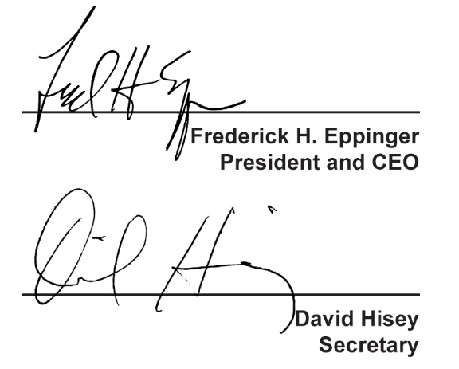
  Countersigned by:
  ___________________________________
  Authorized Countersignature

