

ALTA ENDORSEMENT 44-06 (INSURED MORTGAGE RECORDING-LOAN)
ATTACHED TO POLICY NUMBER ______________________

ISSUED BY

STEWART TITLE GUARANTY COMPANY

File No.: ______________________ | Charge: ______________________

- The insurance provided by this endorsement is subject to the Exclusions from Coverage, the Exceptions from Coverage contained in Schedule B, and the Conditions in the policy.

- The Company insures against loss or damage sustained by the Insured by reason of the failure of the Insured Mortgage to have been recorded in the Public Records as set forth in Section 3 below.

- Paragraph 4 of Schedule A is amended to read as follows:

The Insured Mortgage and its assignments, if any, are described as follows:

Mortgage: ______________________
Mortgagor: ______________________
Mortgagee: ______________________
Dated: ______________________
Recorded: ______________________
Recording/Instrument Number: ______________________

This endorsement is issued as part of the policy. Except as it expressly states, it does not (i) modify any of the terms and provisions of the policy, (ii) modify any prior endorsements, (iii) extend the Date of Policy, or (iv) increase the Amount of Insurance. To the extent a provision of the policy or a previous endorsement is inconsistent with an express provision of this endorsement, this endorsement controls. Otherwise, this endorsement is subject to all of the terms and provisions of the policy and of any prior endorsement.

Date:

 |  | 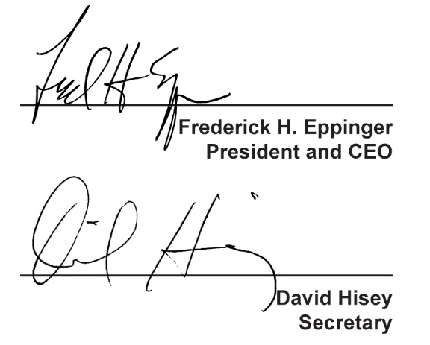
  Countersigned by:
  ___________________________________
  Authorized Countersignature

