

ALTA ENDORSEMENT 33-06 (DISBURSEMENT)
ATTACHED TO POLICY NUMBER ______________________

ISSUED BY
STEWART TITLE GUARANTY COMPANY

File No.: ______________________ | Charge: ______________________

- The Date of Coverage is amended to ______________________
a. The current disbursement is: $______________________
b. The aggregate amount, including the current disbursement, recognized by the Company as disbursed by the Insured is: $______________________
2. Schedule A is amended as follows:
______________________

3. Schedule B is amended as follows:
Part I

______________________

Part II

______________________

This endorsement is issued as part of the policy. Except as it expressly states, it does not (i) modify any of the terms and provisions of the policy, (ii) modify any prior endorsements, (iii) extend the Date of Policy, or (iv) increase the Amount of Insurance. To the extent a provision of the policy or a previous endorsement is inconsistent with an express provision of this endorsement, this endorsement controls. Otherwise, this endorsement is subject to all of the terms and provisions of the policy and of any prior endorsements.

Date:

 |  | 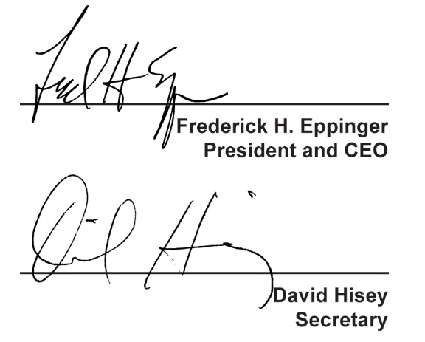
  Countersigned by:
  ___________________________________
  Authorized Countersignature

