

ALTA 34.1 IDENTIFIED EXCEPTION & IDENTIFIED RISK COVERAGE ENDORSEMENT (07-01-2021)
THIS ENDORSEMENT IS ISSUED AS PART OF POLICY NUMBER ______________________

ISSUED BY

STEWART TITLE GUARANTY COMPANY

File No.: ______________________ | Charge: ______________________

1. As used in this endorsement, the following terms mean:
a. “Identified Exception”: Exception _____ of Schedule B.
b. “Identified Risk”: The consequences specified below that may result from the exercise or enforcement of the matter described in the Identified Exception:
__________________________________________________________________________________
__________________________________________________________________________________
__________________________________________________________________________________

2. The Company insures against loss or damage sustained by the Insured by reason of:
a. the exercise or enforcement of an Identified Risk specified in Section 1.b. by an adverse party; or
b. the release of a prospective purchaser or lessee of the Title or a lender on the Title from the obligation to purchase, lease, or lend, as a result of the Identified Risk arising out of the Identified Exception, but only if:
i. there is a contractual condition requiring the delivery of marketable title; and
ii. neither the Company nor any other title insurance company will insure over the Identified Risk with the same coverage as in this endorsement.

3. This endorsement does not obligate the Company to establish the Title free of the Identified Exception or to eliminate the Identified Risk. The Company does not assume any liability for loss or damage arising out of the Identified Exception other than the Identified Risk. If the Company establishes the Title free of the Identified Risk, Condition 9.a. of the policy applies.

This endorsement is issued as part of the policy. Except as it expressly states, it does not (i) modify any of the terms and provisions of the policy, (ii) modify any prior endorsements, (iii) extend the Date of Policy, or (iv) increase the Amount of Insurance. To the extent a provision of the policy or a previous endorsement is inconsistent with an express provision of this endorsement, this endorsement controls. Otherwise, this endorsement is subject to all of the terms and provisions of the policy and of any prior endorsements.

Date:

 |  | 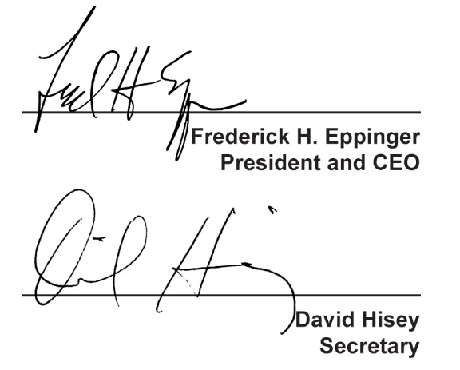
  Countersigned by:
  ___________________________________
  Authorized Countersignature

