

ALTA ENDORSEMENT 36.6-06 (ENERGY PROJECT–ENCROACHMENTS)
ATTACHED TO POLICY NUMBER ______________________

ISSUED BY
STEWART TITLE GUARANTY COMPANY

File No.: ______________________ | Charge: ______________________

- The insurance provided by this endorsement is subject to the exclusions in Section 4 of this endorsement; and the Exclusions from Coverage, the Exceptions from Coverage contained in Schedule B, and the Conditions in the policy.
- For purposes of this endorsement only:
  - "Electricity Facility" means an electricity generating facility that may include one or more of the following: a substation; a transmission, distribution or collector line; an interconnection, inverter, transformer, generator, turbine, array, solar panel, or module; a circuit breaker, footing, tower pole, cross-arm, guy line, anchor, wire, control system, communications or radio relay system, safety protection facility, road, and other building, structure, fixture, machinery, equipment, appliance and item associated with or incidental to the generation, conversion, storage, switching, metering, step-up, step-down, inversion, transmission, conducting, wheeling, sale or other use or conveyance of electricity, on the Land at Date of Policy or to be built or constructed on the Land in the locations according to the Plans, that by law constitutes real property.
  - "Plans" means the survey, site and elevation plans or other depictions or drawings prepared by ______________________ dated ______________________, last revised ______________________ designated as ______________________ consisting of ______________________ sheets.
  - "Severable Improvement" means property affixed to the Land at Date of Policy or to be affixed to the Land in the locations according to the Plans, that would constitute an Electricity Facility but for its characterization as personal property, and that by law does not constitute real property because (a) of its character and manner of attachment to the Land and (b) the property can be severed from the Land without causing material damage to the property or to the Land.
- The Company insures against loss or damage sustained by the Insured by reason of:
  - An encroachment of any Electricity Facility or Severable Improvement located on the Land onto adjoining land or onto that portion of the Land subject to an easement, unless an exception in Schedule B of the policy identifies the encroachment;
  - An encroachment of an improvement located on adjoining land onto the Land at Date of Policy, unless an exception in Schedule B of the policy identifies the encroachment;
  - Enforced removal of any Electricity Facility or Severable Improvement, as a result of an encroachment by the Electricity Facility or Severable Improvement onto any portion of the Land subject to any easement, in the event that the owners of the easement shall, for the purpose of exercising the right of use or maintenance of the easement, compel removal or relocation of the encroaching Electricity Facility or Severable Improvement; or
  - Damage to any Electricity Facility or Severable Improvement that is located on or encroaches onto that portion of the Land subject to an easement excepted in Schedule B, which damage results from the exercise of the right to maintain the easement for the purpose for which it was granted or reserved; or
  - The coverage of Sections 3.c. and 3.d. shall not apply to the encroachments listed in Exception(s) _______ of Schedule B.

- This endorsement does not insure against loss or damage (and the Company will not pay costs, attorneys' fees, or expenses) resulting from contamination, explosion, fire, flooding, vibration, fracturing, earthquake or subsidence.
This endorsement is issued as part of the policy. Except as it expressly states, it does not (i) modify any of the terms and provisions of the policy, (ii) modify any prior endorsements, (iii) extend the Date of Policy, or (iv) increase the Amount of Insurance. To the extent a provision of the policy or a previous endorsement is inconsistent with an express provision of this endorsement, this endorsement controls. Otherwise, this endorsement is subject to all of the terms and provisions of the policy and of any prior endorsements.

Date:

 |  | 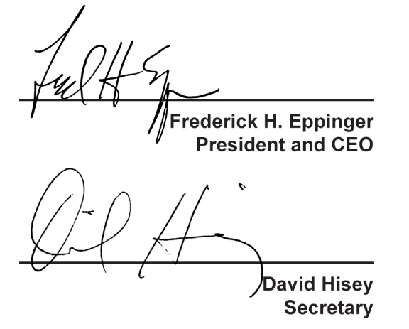
  Countersigned by:
  ___________________________________
  Authorized Countersignature

