

ALTA endorsement 40.1-06 (TAx Credit – defined Amount – Owner’s Policy)
ATTACHED TO POLICY NUMBER ____________________

ISSUED BY
STEWART TITLE GUARANTY COMPANY

File No.: ____________ | Charge: _________

- This endorsement is subject to the exclusions in Section 4 of this endorsement; and the Exclusions from Coverage, the Exceptions from Coverage contained in Schedule B, and the Conditions in the policy.
- For purposes of this endorsement only:
  - “Tax Credit Investor” means __________________________.
  - “Tax Credit” means a tax credit in effect at Date of Policy pertaining to the Land that is available to the Tax Credit Investor under an applicable section of the Internal Revenue Code or other applicable law.
  - “Additional Amount of Insurance” means $____________. It is in addition to the Amount of Insurance stated in Schedule A and is applicable only to loss or damage payable to the Tax Credit Investor under this endorsement.
- The Company insures against loss or damage, not exceeding the Additional Amount of Insurance, sustained by the Tax Credit Investor by a reduction in a Tax Credit that is caused solely by a defect, lien, encumbrance or other matter insured against by this policy. The Company has no liability to the Tax Credit Investor under this endorsement until:
a. its liability and the extent of a loss insured against by the policy have been definitely fixed in accordance with the Conditions; and
b. the Tax Credit Investor establishes the reduction in the amount of a Tax Credit.
- This endorsement does not insure against loss or damage (and the Company will not pay costs, attorneys’ fees, or expenses) incurred in defending or establishing:
  - the eligibility of the Tax Credit Investor or the Land for a Tax Credit;
  - that the Tax Credit Investor or the Land is entitled to a Tax Credit; or
  - the existence, ownership, or amount of a Tax Credit.
This endorsement is issued as part of the policy. Except to the extent expressly stated, it does not (i) modify any of the terms and provisions of the policy, (ii) modify any prior endorsements, (iii) extend the Date of Policy, or (iv) increase the Amount of Insurance. To the extent a provision of the policy or a previous endorsement is inconsistent with an express provision of this endorsement, this endorsement controls. Otherwise, this endorsement is subject to all of the terms and provisions of the policy and of any prior endorsements.

Date:

 |  | 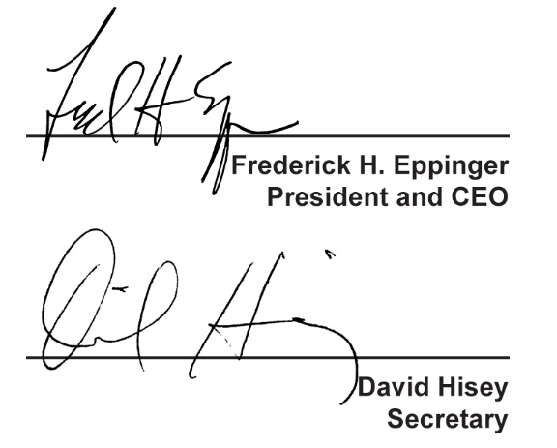
  Countersigned by:
  ___________________________________
  Authorized Countersignature

