

ALTA ENDORSEMENT 41.3-06 (WATER-LAND UNDER DEVELOPMENT)
ATTACHED TO POLICY NUMBER ______________________

ISSUED BY

STEWART TITLE GUARANTY COMPANY

File No.: ______________________ | Charge: ______________________

- The insurance provided by this endorsement is subject to the exclusion in Section 4 of this endorsement; and the Exclusions from Coverage, the Exceptions from Coverage contained in Schedule B, and the Conditions in the policy.
- For purposes of this endorsement only:
  - “Improvement” means a building, structure located on the surface of the Land, and any paved road, walkway, parking area, driveway, or curb, affixed to the Land at Date of Policy and that by law constitutes real property, but excluding any crops, landscaping, lawn, shrubbery, or trees.
  - “Future Improvement” means a building, structure, and any paved road, walkway, parking area, driveway, or curb to be constructed on or affixed to the Land in the locations according to the Plans and that by law will constitute real property, but excluding any crops, landscaping, lawn, shrubbery, or trees.
  - “Plans” means the survey, site and elevation plans or other depictions or drawings prepared by ______________________ dated ___________, last revised _________, designated as ______________________ consisting of ______ sheets.
3. The Company insures against loss or damage sustained by the Insured by reason of the enforced removal or alteration of an Improvement or a Future Improvement, resulting from the future exercise of any right existing at Date of Policy to use the surface of the Land for the extraction or development of water excepted from the description of the Land or excepted in Schedule B.
4. This endorsement does not insure against loss or damage (and the Company will not pay costs, attorneys' fees, or expenses) resulting from:
- contamination, explosion, fire, flooding, vibration, fracturing, earthquake or subsidence; or
- negligence by a person or an Entity exercising a right to extract or develop water; or
- the exercise of the rights described in (______________________).
This endorsement is issued as part of the policy. Except as it expressly states, it does not (i) modify any of the terms and provisions of the policy, (ii) modify any prior endorsements, (iii) extend the Date of Policy, or (iv) increase the Amount of Insurance. To the extent a provision of the policy or a previous endorsement is inconsistent with an express provision of this endorsement, this endorsement controls. Otherwise, this endorsement is subject to all of the terms and provisions of the policy and of any prior endorsements.

Date:

 |  | 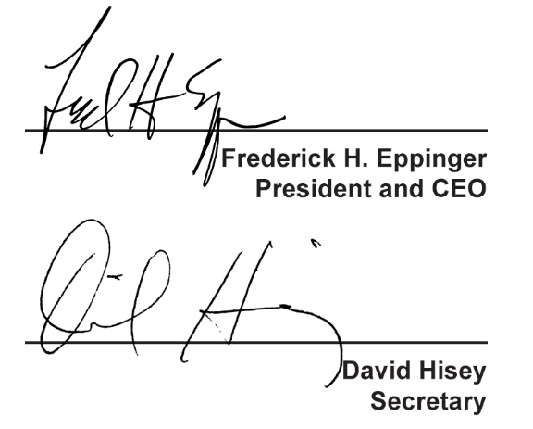
  Countersigned by:
  ___________________________________
  Authorized Countersignature

