

LA 100 ENDORSEMENT (COLLATERAL MORTGAGE)
ATTACHED TO POLICY NUMBER

ISSUED BY
STEWART TITLE GUARANTY COMPANY

File No: | Charge:

- The insurance for Advances added by Section 2 of this endorsement is subject to the exclusions in Section 3 of this endorsement and the Exclusions from Coverage in the policy, except Exclusion 3(d), the provisions of the Conditions, and the exceptions contained in Schedule B.
  - “Insured,” as defined in Condition 1(e), is modified to exclude any transferee or assignee of the insured mortgage or Collateral Note unless expressly acknowledged by endorsement issued after compliance with such requirements with respect to the form and substance of the transfer and assignment and other matters, as the Company may impose.
  - “Collateral Mortgage Note,” as used in this endorsement, is the instrument secured by and described in the Insured Mortgage executed for the purpose of being issued, pledged or otherwise used as security for another obligation pursuant to Louisiana law.
  - “Security Interest,” as used in this endorsement, shall mean a pledge of, or possessory security interest in, an instrument.
  - “Indebtedness,” as defined in Condition 1(d), is amended to include an obligation secured by a valid, enforceable and perfected Security Interest in the Collateral Mortgage Note.
  - “Advances,” as used in this endorsement, shall mean only those advances of principal indebtedness made after Date of Policy (including such advances used to pay accrued interest) secured by a valid, enforceable and perfected Security Interest in the Collateral Mortgage Note, except that it shall not include any principal disbursed after the Insured has Knowledge of any sale or transfer of all or any portion of the estate or interest encumbered by the Insured Mortgage other than amounts secured by the Insured Mortgage to pay expenses of foreclosure, taxes and insurance, assure compliance with laws, or to protect the lien of the Insured Mortgage before the time of acquisition of the Title, and reasonable amounts expended to prevent deterioration of improvements, together with interest on those advances.
- The Company insures against loss or damage sustained by the Insured by reason of:
  - The invalidity or unenforceability of the lien of the Insured Mortgage as security for each Advance.
  - The priority of any lien or encumbrance over the lien of the Insured Mortgage as security for each Advance.
  - The invalidity or unenforceability or loss of priority of the lien of the Insured Mortgage as security for the Indebtedness and Advances resulting from (i) re-Advances and repayments of Indebtedness, (ii) lack of outstanding Indebtedness before an Advance, or (iii) the failure of the Insured Mortgage to comply with the requirements of state law of the state in which the Land is located to secure Advances.
- This endorsement does not insure against loss or damage (and the Company will not pay costs, attorneys’ fees, or expenses) resulting from:
  - Advances made after a Petition for Relief under the Bankruptcy Code (11 U.S.C) has been filed by or on behalf of the mortgagor.
  - The loss of priority of the lien of the Insured Mortgage, as security for Advances, to the lien of real estate taxes or assessments on the Title imposed by governmental authority arising after Date of Policy.

  - The loss of priority of the lien of the Insured Mortgage as security for any Advance, to a federal tax lien, which Advance is made after the earlier of (i) Knowledge of the Insured that a federal tax lien was filed against the mortgagor, or (ii) the expiration of more than forty-five days after notice of a federal tax lien filed against the mortgagor.
  - The loss of priority of the lien of the Insured Mortgage as security for Advances to any federal or state environmental protection lien.
  - Usury, or any consumer credit protection or truth-in-lending law.
  - The loss of priority of the lien of the Insured Mortgage resulting from the unenforceability of the Security Interest in the Collateral Mortgage Note at any time after Date of Policy by virtue of a termination, remission or release of possession of the Collateral Mortgage Note or otherwise.
  - Any mechanic’s or materialmen’s lien.

    - Regardless of the face amount of the Collateral Mortgage Note or the stated maximum amount of indebtedness secured by the Insured Mortgage, the Amount of Insurance is based upon the maximum anticipated principal indebtedness to be secured by the Insured Mortgage as represented by the Insured (including Advances); and the Amount of Insurance may not be increased except by endorsement after compliance with such additional requirements as the Company may impose, including payment of an additional premium.

This endorsement is issued as part of the policy. Except as it expressly states, it does not (i) modify any of the terms and provisions of the policy, (ii) modify any prior endorsements, (iii) extend the Date of Policy, or (iv) increase the Amount of Insurance. To the extent a provision of the policy or a previous endorsement is inconsistent with an express provision of this endorsement, this endorsement controls. Otherwise, this endorsement is subject to all of the terms and provisions of the policy and of any prior endorsements.

Date:

 |  | 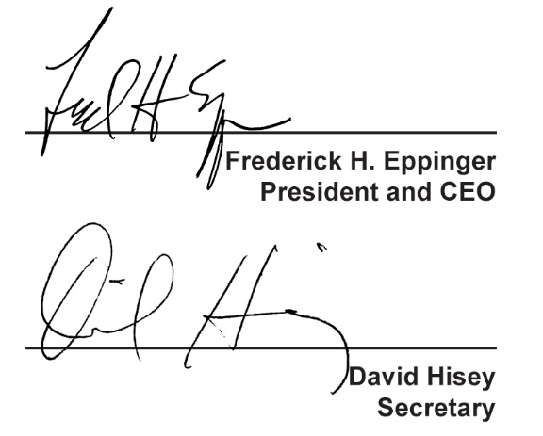
  Countersigned by:
  ___________________________________
  Authorized Countersignature

