

LA 102 ENDORSEMENT (INCREASED COVERAGE)
ATTACHED TO POLICY NUMBER

ISSUED BY
STEWART TITLE GUARANTY COMPANY

File No: | Charge:

As of the date of this Endorsement, the “Amount of Insurance” on Schedule A is deleted and the following “Amount of Insurance” is substituted:

$

Under this endorsement, we do not cover title risks or insure against matters:
  - Created, suffered, assumed, or agree to by you (the insured), or
  - Known to you (the insured) but not to us (the company) at the date of this endorsement unless they appeared in the Public Records on the Policy Date.

This endorsement does not change the Policy Date. The terms of the Policy apply to this endorsement.

This endorsement is issued as part of the policy. Except as it expressly states, it does not (i) modify any of the terms and provisions of the policy, (ii) modify any prior endorsements, (iii) extend the Date of Policy, or (iv) increase the Amount of Insurance. To the extent a provision of the policy or a previous endorsement is inconsistent with an express provision of this endorsement, this endorsement controls. Otherwise, this endorsement is subject to all of the terms and provisions of the policy and of any prior endorsements.

Date:

 |  | 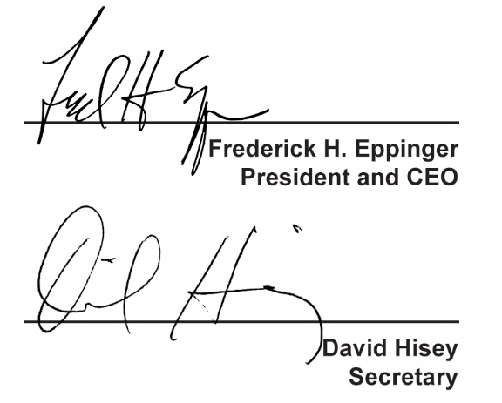
  Countersigned by:
  ___________________________________
  Authorized Countersignature

