

LA 103 ENDORSEMENT (FOUNDATION)
ATTACHED TO POLICY NUMBER

ISSUED BY
STEWART TITLE GUARANTY COMPANY

File No: | Charge:

The Company hereby insures the owner of the indebtedness secured by the insured mortgage against loss or damage which the insured shall sustain by reason of:
- The failure of the foundation of the structure under construction on the land to be within the boundary lines of the land as of the date hereof;
- The location of the foundation, as of the date hereof, being in violation of the covenants, conditions or restrictions referred to in Schedule B as of the date hereof
- The foundation encroaching, as of the date hereof, onto any of the easements referred to in Schedule B.

Date of Endorsement:

This endorsement is issued as part of the policy. Except as it expressly states, it does not (i) modify any of the terms and provisions of the policy, (ii) modify any prior endorsements, (iii) extend the Date of Policy, or (iv) increase the Amount of Insurance. To the extent a provision of the policy or a previous endorsement is inconsistent with an express provision of this endorsement, this endorsement controls. Otherwise, this endorsement is subject to all of the terms and provisions of the policy and of any prior endorsements.

Date:

 |  | 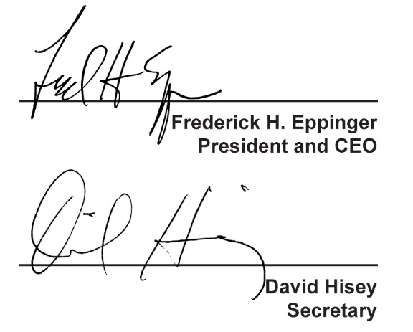
  Countersigned by:
  ___________________________________
  Authorized Countersignature

