

LA 104 ENDORSEMENT (CO-INSURANCE – SINGLE POLICY)
MODIFIED TO ADD LIMITED JOINT & SEVERAL LIABILITY PROVISION
ATTACHED TO POLICY NUMBER

ISSUED BY
STEWART TITLE GUARANTY COMPANY

File No: | Charge:

Attached to and made a part of Issuing Co-Insurer’s Policy Number (“Co-Insurance Policy”). Each title insurance company executing this Co-Insurance Endorsement, other than the Issuing Co-Insurer, shall be referred to as a “Co-Insurer.” Issuing Co-Insurer and each Co-Insurer are collectively referred to as “Co-Insuring Companies.”
- By issuing this endorsement to the Co-Insurance Policy, each of the Co-Insuring Companies adopts the Co-Insurance Policy’s Covered Risks, Exclusions, Conditions, Schedules and Endorsements, subject to the limitations of this endorsement.
Co-Insuring  Companies | Name and Address | Policy Number  File Number | Amount of  Insurance | Percentage  of Liability
Issuing Co-Insurer |  |  |  | %
Co-Insurer |  |  |  | %
Co-Insurer |  |  |  | %
Co-Insurer |  |  |  | %
Co-Insurer |  |  |  | %
Co-Insurer |  |  |  | %
Aggregate Amount
of Insurance

- Subject to Section 3 below, each of the Co-Insuring Companies shall be liable to the Insured only for its Percentage of Liability of: (a) the total of loss or damage under the Co-Insurance Policy, but in no event greater than its respective Amount of Insurance set forth in this endorsement; and (b) costs, attorneys’ fees and expenses provided for in the Conditions.
- Each of the Co-Insuring Companies shall be jointly and severally liable to the Insured for the first Dollars ($ ) of loss or damage compensable under the Co-Insurance Policy, including costs, attorneys’ fees and expenses provided for in the Conditions. In no event shall the liability of the Issuing Co-Insurer and each Co-Insurer exceed the greater of: (a) the amount of its respective liability under the joint-and-several liability provision in this Section 3 above; or (b) its respective Percentage of Liability as provided and subject to the limitation in Section 2 above.

- Any notice of claim and any other notice or statement in writing required to be given under the Co-Insurance Policy must be given to each of the Co-Insuring Companies at its address set forth above.
- Any endorsement to the Co-Insurance Policy issued after the date of this Co-Insurance Endorsement must be signed by each of the Co-Insuring Companies by its authorized officer or agent.
- This Co-Insurance Endorsement is effective as of the Date of Policy of the Co-Insurance Policy. This Co-Insurance Endorsement may be executed in counterparts.
This endorsement is issued as part of the Co-Insurance Policy. Except as it expressly states, it does not (i) modify any of the terms and provisions of the policy, (ii) modify any prior endorsements, (iii) extend the Date of Policy, or (iv) increase the Amount of Insurance. To the extent a provision of the policy or a previous endorsement is inconsistent with an express provision of this endorsement, this endorsement controls. Otherwise, this endorsement is subject to all of the terms and provisions of the policy and of any prior endorsements.
Date:

Issuing Co-Insurer | Co-Insurer | Co-Insurer
By: ___________________________ | By: ___________________________ | By: _________________________
Issuing Co-Insurer | Co-Insurer | Co-Insurer
By: ___________________________ | By: ___________________________ | By: _________________________

 |  | 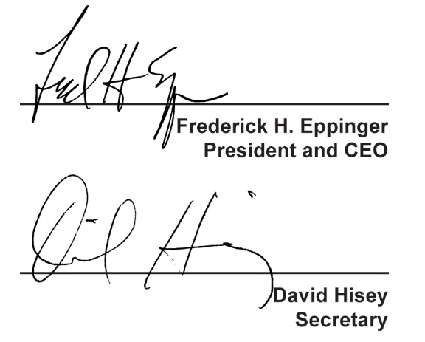
  Countersigned by:
  ___________________________________
  Authorized Countersignature

