

LA 105 ENDORSEMENT (SPECIAL MEASURE OF LOSS – LOAN POLICY)
ATTACHED TO POLICY NUMBER

ISSUED BY
STEWART TITLE GUARANTY COMPANY

File No.: | Charge:

The Company agrees that, for the purposes determining the extent of liability of the Company for loss or damage by reason of any defect, lien, encumbrance or other matter insured against by this policy (“Defect”), Condition 8(a)(iii) shall be replaced in its entirety to read as follows:

"(ii) the difference between (A) the value of the Title as insured without the Defect, taking into consideration, at the time notice of claim is given to the Company, the use or intended use of the Land as a single integrated site for and (B) the value of the Title subject to the Defect, taking into consideration the factors set forth in (A) above."

This endorsement is issued as part of the policy. Except as it expressly states, it does not (i) modify any of the terms and provisions of the policy, (ii) modify any prior endorsements, (iii) extend the Date of Policy, or (iv) increase the Amount of Insurance. To the extent a provision of the policy or a previous endorsement is inconsistent with an express provision of this endorsement, this endorsement controls. Otherwise, this endorsement is subject to all of the terms and provisions of the policy and of any prior endorsements.

Date:

 |  | 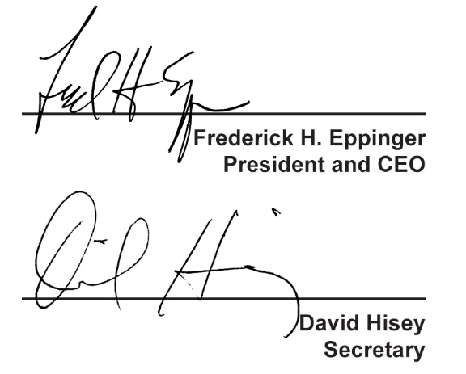
  Countersigned by:
  ___________________________________
  Authorized Countersignature

