

LA108 ENDORSEMENT (DATE DOWN FOR LOAN POLICY)
ATTACHED TO POLICY NUMBER

ISSUED BY
STEWART TITLE GUARANTY COMPANY

File No.: | Charge:

The Policy is hereby amended as follows:
- Subject to the provisions in paragraphs 5 and 6 below, Schedule A of the Policy is amended to reflect a Date of Policy of .
- At Date of Policy, Title is vested in: .
- The following items are added to Schedule B, Part I, of the Policy: (List recorded items here. If none, state “None”)

- The following items are added to Schedule B, Part II, of the Policy: (List recorded items here. If none, state “None”)

- The coverage of each endorsement previously made a part of the Policy shall retain (“Original Date of Policy”) as the Date of Policy applicable to it.
- This Endorsement does not insure against loss or damage, and the Company will not pay costs, attorneys’ fees, or expenses resulting from:
  - The Exceptions shown in Schedule B of the Policy and in any prior endorsement to the Policy,
  - Any defect, lien, encumbrance, adverse claim, or other matter that would be disclosed by an accurate and complete land survey of the land or a physical inspection of the Land made subsequent to the Original Date of Policy,
  - Any and all liens for services, labor, materials, or equipment furnished in connection with any improvement, repair, or renovation on the land subsequent to the Original Date of Policy and not recorded or filed in the Public Records prior to the Date of Policy,
  - General and special taxes and assessments for , and subsequent years, not yet due and payable.
  - Any claim, by reason of the operation of federal bankruptcy, state insolvency, or similar creditors’ rights laws, that the transaction giving rise to the issuance of this Endorsement is based on:
    - A fraudulent conveyance or fraudulent transfer; or
    - A preferential transfer
This endorsement is issued as part of the policy. Except as it expressly states, it does not (i) modify any of the terms and provisions of the policy, (ii) modify any prior endorsement, (iii) extend the Date of Policy, or (iv) increase the Amount of Insurance. To the extent a provision of the policy or a previous endorsement is inconsistent with an express provision of this endorsement, this endorsement controls. Otherwise, this endorsement is subject to all of the terms and provisions of the policy and of any prior endorsements.

 |  | 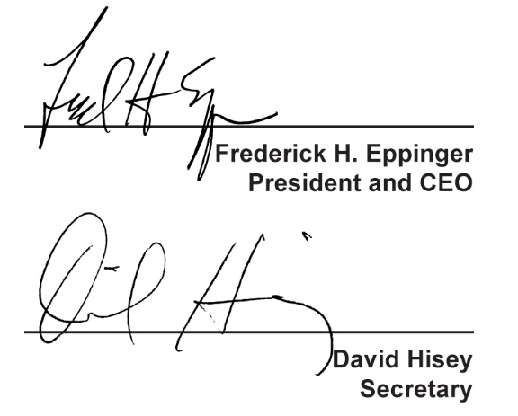
  Countersigned by:
  ___________________________________
  Authorized Countersignature

