

LA109 LIMITED CONSTRUCTION ADVANCE ENDORSEMENT (LOAN POLICY)
THIS ENDORSEMENT IS ISSUED AS PART OF POLICY NUMBER

ISSUED BY
STEWART TITLE GUARANTY COMPANY

File No.: | Charge:

- The Public Records of the Parish in which the Land is located have been reviewed to the following date: .
- The following items are added to Schedule B, Part I, of the Policy: (List recorded items here. If none, state “None”)

- The following items are added to Schedule B, Part II, of the Policy: (List recorded items here. If none, state “None”)

- This Endorsement does not change the Date of Policy and does not advance the effective date of any Endorsement included with the aforementioned Policy.
- The Company recognizes:
  - The current disbursement is: $ .
  - The aggregate amount, including the current disbursement, disbursed by the Insured is: $ .

This endorsement is issued as part of the policy. Except as it expressly states, it does not (i) modify any of the terms and provisions of the policy, (ii) modify any prior endorsements, (iii) extend the Date of Policy, or (iv) increase the Amount of Insurance. To the extent a provision of the policy or a previous endorsement is inconsistent with an express provision of this endorsement, this endorsement controls. Otherwise, this endorsement is subject to all of the terms and provisions of the policy and of any prior endorsements.

Date:

 |  | 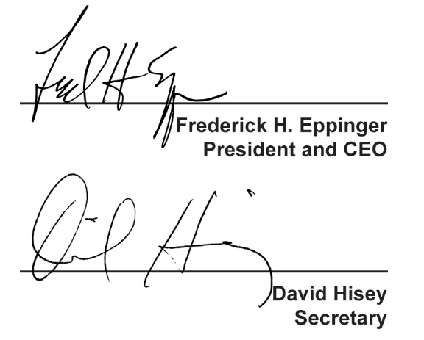
  Countersigned by:
  ___________________________________
  Authorized Countersignature

