

GENERAL ENDORSEMENT
ATTACHED TO POLICY NUMBER

ISSUED BY
STEWART TITLE GUARANTY COMPANY

File No.: | Charge: - 0 -

Place cursor here and Begin typing

This endorsement is issued as part of the policy. Except as it expressly states, it does not (i) modify any of the terms and provisions of the policy, (ii) modify any prior endorsements, (iii) extend the Date of Policy, or (iv) increase the Amount of Insurance. To the extent a provision of the policy or a previous endorsement is inconsistent with an express provision of this endorsement, this endorsement controls. Otherwise, this endorsement is subject to all of the terms and provisions of the policy and of any prior endorsements.

Date:

 |  | 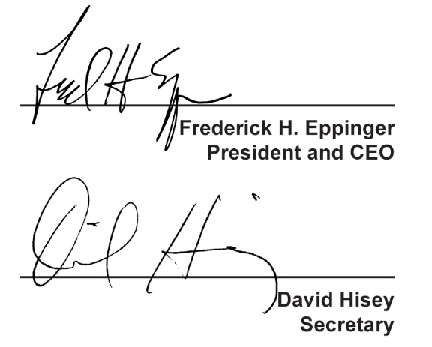
  Countersigned by:
  ___________________________________
  Authorized Countersignature

