

ALTA 49.1 ENDORSEMENT – FORGERY - EXISTING OWNER’S POLICY - RESIDENTIAL
THIS ENDORSEMENT IS ISSUED AS PART OF POLICY NUMBER

ISSUED BY
STEWART TITLE GUARANTY COMPANY

File No.: | Charge:

1. Any capitalized terms not otherwise defined in this endorsement incorporate by reference the definitions found in the 2021 ALTA Owner’s Policy of Title Insurance. Additionally, for purposes of this endorsement, the following terms mean:
- “Date of Endorsement”: ____________________________.
- “Estate Planning Entity”: a legal entity, a trust, or a trustee of a trust, if the entity or trust is established by a Natural Person for the purpose of planning the disposition of that person’s estate.
- “Natural Person”: a human being, not a commercial or legal organization or entity.
2. This endorsement is valid only if:
- The Land is improved with an existing one-to-four family residence;
- Each party named in Item 1 of Schedule A is a Natural Person or Estate Planning Entity; and
- It is issued to the Company’s existing ALTA Owner’s Policy, and not an ALTA Homeowner’s Policy of Title Insurance.
3. The Company insures against loss or damage sustained or incurred by the Insured by reason of a defect in the Title caused by a forgery of a deed or Mortgage recorded in the Public Records after the Date of Endorsement in which the Insured was impersonated as the grantor.
4. Solely for purposes of the coverage provided by this endorsement and not otherwise:
- The Company agrees that it will not assert the provisions of Exclusion 3.d. to deny liability for loss or damage; and
- Exclusion 3.b. is revised and restated in full as follows:
“not Known to the Company but Known to the Insured Claimant, and not disclosed in writing to the Company by the Insured Claimant prior to the Date of Endorsement;”.
This endorsement is issued as part of the policy. Except as it expressly states, it does not (i) modify any of the terms and provisions of the policy, (ii) modify any prior endorsements, (iii) extend the Date of Policy, or (iv) increase the Amount of Insurance. To the extent a provision of the policy or a previous endorsement is inconsistent with an express provision of this endorsement, this endorsement controls. Otherwise, this endorsement is subject to all of the terms and provisions of the policy and of any prior endorsements.

Date:

 |  | 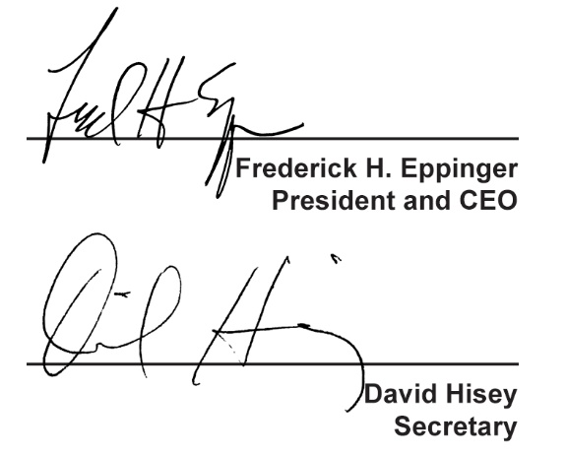
  Countersigned by:
  ___________________________________
  Authorized Countersignature

