

ALTA COMMITMENT FOR TITLE INSURANCE -- MODIFIED LA (07-01-2021) EFF 10-01-2022

ISSUED BY
STEWART TITLE GUARANTY COMPANY

NOTICE

IMPORTANT - READ CAREFULLY: THIS COMMITMENT IS AN OFFER TO ISSUE ONE OR MORE TITLE INSURANCE POLICIES. ALL CLAIMS OR REMEDIES SOUGHT AGAINST THE COMPANY INVOLVING THE CONTENT OF THIS COMMITMENT OR THE POLICY MUST BE BASED SOLELY IN CONTRACT.

THIS COMMITMENT IS NOT AN ABSTRACT OF TITLE, REPORT OF THE CONDITION OF TITLE, LEGAL OPINION, OPINION OF TITLE, OR OTHER REPRESENTATION OF THE STATUS OF TITLE. THE PROCEDURES USED BY THE COMPANY TO DETERMINE INSURABILITY OF THE TITLE, INCLUDING ANY SEARCH AND EXAMINATION, ARE PROPRIETARY TO THE COMPANY, WERE PERFORMED SOLELY FOR THE BENEFIT OF THE COMPANY, AND CREATE NO EXTRACONTRACTUAL LIABILITY TO ANY PERSON, INCLUDING A PROPOSED INSURED.

THE COMPANY’S OBLIGATION UNDER THIS COMMITMENT IS TO ISSUE A POLICY TO A PROPOSED INSURED IDENTIFIED IN SCHEDULE A IN ACCORDANCE WITH THE TERMS AND PROVISIONS OF THIS COMMITMENT. THE COMPANY HAS NO LIABILITY OR OBLIGATION INVOLVING THE CONTENT OF THIS COMMITMENT TO ANY OTHER PERSON.

COMMITMENT TO ISSUE POLICY
Subject to the Notice; Schedule B, Part I - Requirements; Schedule B, Part II - Exceptions; and the Commitment Conditions, STEWART TITLE GUARANTY COMPANY, a Texas corporation (the “Company”), commits to issue the Policy according to the terms and provisions of this Commitment. This Commitment is effective as of the Commitment Date shown in Schedule A for each Policy described in Schedule A, only when the Company has entered in Schedule A both the specified dollar amount as the Proposed Amount of Insurance and the name of the Proposed Insured.
If all of the Schedule B, Part I - Requirements have not been met within 180 days after the Commitment Date, this Commitment terminates and the Company’s liability and obligation end.

 | 
  Countersigned by:
  Authorized Countersignature
  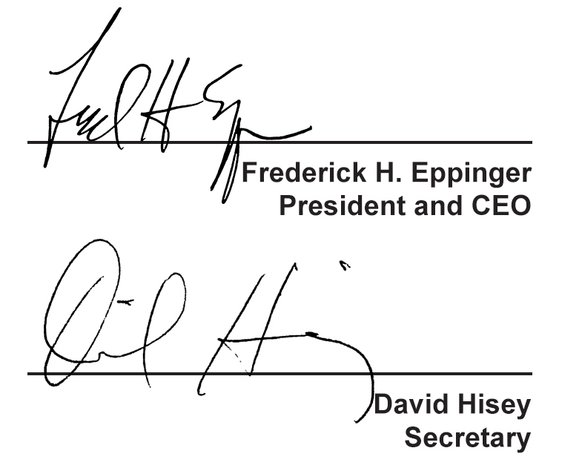

COMMITMENT CONDITIONS

- DEFINITIONS
a. “Discriminatory Covenant”: Any covenant, condition, restriction, or limitation that is unenforceable under applicable law because it illegally discriminates against a class of individuals based on personal characteristics such as race, color, religion, sex, sexual orientation, gender identity, familial status, disability, national origin, or other legally protected class.
b. “Knowledge” or “Known”: Actual knowledge or actual notice, but not constructive notice imparted by the Public Records.
c. “Land”: The land described in Item 5 of Schedule A and improvements located on that land that by State law constitute real property. The term “Land” does not include any property beyond that described in Schedule A, nor any right, title, interest, estate, or easement in any abutting street, road, avenue, alley, lane, right-of-way, body of water, or waterway, but does not modify or limit the extent that a right of access to and from the Land is to be insured by the Policy.
d. “Mortgage”: A mortgage, deed of trust, trust deed, security deed, or other real property security instrument, including one evidenced by electronic means authorized by law.
e. “Policy”: Each contract of title insurance, in a form adopted by the American Land Title Association, issued or to be issued by the Company pursuant to this Commitment.
f. “Proposed Amount of Insurance”: Each dollar amount specified in Schedule A as the Proposed Amount of Insurance of each Policy to be issued pursuant to this Commitment.
g. “Proposed Insured”: Each person identified in Schedule A as the Proposed Insured of each Policy to be issued pursuant to this Commitment.
h. “Public Records”: The recording or filing system established under State statutes in effect at the Commitment Date under which a document must be recorded or filed to impart constructive notice of matters relating to the Title to a purchaser for value without Knowledge. The term “Public Records” does not include any other recording or filing system, including any pertaining to environmental remediation or protection, planning, permitting, zoning, licensing, building, health, public safety, or national security matters.
i. “State”: The state or commonwealth of the United States within whose exterior boundaries the Land is located. The term “State” also includes the District of Columbia, the Commonwealth of Puerto Rico, the U.S. Virgin Islands, and Guam.
j. “Title”: The estate or interest in the Land identified in Item 3 of Schedule A.
- If all of the Schedule B, Part I - Requirements have not been met within the time period specified in the Commitment to Issue Policy, this Commitment terminates and the Company’s liability and obligation end.
- The Company’s liability and obligation is limited by and this Commitment is not valid without:
  - the Notice;
  - the Commitment to Issue Policy;
  - the Commitment Conditions;
  - Schedule A;
  - Schedule B, Part I - Requirements;
  - Schedule B, Part II - Exceptions; and
  - a countersignature by the Company or its issuing agent that may be in electronic form.
- COMPANY’S RIGHT TO AMEND
The Company may amend this Commitment at any time. If the Company amends this Commitment to add a defect, lien, encumbrance, adverse claim, or other matter recorded in the Public Records prior to the Commitment Date, any liability of the Company is limited by Commitment Condition 5. The Company is not liable for any other amendment to this Commitment.
- LIMITATIONS OF LIABILITY
  - The Company’s liability under Commitment Condition 4 is limited to the Proposed Insured’s actual expense incurred in the interval between the Company’s delivery to the Proposed Insured of the Commitment and the delivery of the amended Commitment, resulting from the Proposed Insured’s good faith reliance to:
- comply with the Schedule B, Part I - Requirements;
- eliminate, with the Company’s written consent, any Schedule B, Part II - Exceptions; or
- acquire the Title or create the Mortgage covered by this Commitment.
  - The Company is not liable under Commitment Condition 5.a. if the Proposed Insured requested the amendment or had Knowledge of the matter and did not notify the Company about it in writing.
  - The Company is only liable under Commitment Condition 4 if the Proposed Insured would not have incurred the expense had the Commitment included the added matter when the Commitment was first delivered to the Proposed Insured.
  - The Company’s liability does not exceed the lesser of the Proposed Insured’s actual expense incurred in good faith and described in Commitment Condition 5.a. or the Proposed Amount of Insurance.
  - The Company is not liable for the content of the Transaction Identification Data, if any.
f. The Company is not obligated to issue the Policy referred to in this Commitment unless all of the Schedule B, Part I—Requirements have been met to the satisfaction of the Company.
g. The Company’s liability is further limited by the terms and provisions of the Policy to be issued to the Proposed Insured.
- LIABILITY OF THE COMPANY MUST BE BASED ON THIS COMMITMENT; CHOICE OF LAW AND CHOICE OF FORUM
a. Only a Proposed Insured identified in Schedule A, and no other person, may make a claim under this Commitment.
b. Any claim must be based in contract under the State law of the State where the Land is located and is restricted to the terms and provisions of this Commitment. Any litigation or other proceeding brought by the Proposed Insured against the Company must be filed only in a State or federal court having jurisdiction.
c. This Commitment, as last revised, is the exclusive and entire agreement between the parties with respect to the subject matter of this Commitment and supersedes all prior commitment negotiations, representations, and proposals of any kind, whether written or oral, express or implied, relating to the subject matter of this Commitment.
d. The deletion or modification of any Schedule B, Part II—Exception does not constitute an agreement or obligation to provide coverage beyond the terms and provisions of this Commitment or the Policy.
e. Any amendment or endorsement to this Commitment must be in writing and authenticated by a person authorized by the Company.
f. When the Policy is issued, all liability and obligation under this Commitment will end and the Company’s only liability will be under the Policy.
- IF THIS COMMITMENT IS ISSUED BY AN ISSUING AGENT
The issuing agent is the Company’s agent only for the limited purpose of issuing title insurance commitments and policies. The issuing agent is not the Company’s agent for closing, settlement, escrow, or any other purpose.
- PRO-FORMA POLICY
The Company may provide, at the request of a Proposed Insured, a pro-forma policy illustrating the coverage that the Company may provide. A pro-forma policy neither reflects the status of Title at the time that the pro-forma policy is delivered to a Proposed Insured, nor is it a commitment to insure.
9. CLAIMS PROCEDURES
This Commitment incorporates by reference all Conditions for making a claim in the Policy to be issued to the Proposed Insured. Commitment Condition 9 does not modify the limitations of liability in Commitment Conditions 5 and 6.
10. CLASS ACTION (INTENTIONALLY DELETED)
- ARBITRATION (INTENTIONALLY DELETED)

STEWART TITLE GUARANTY COMPANY

All notices required to be given the Company and any statement in writing required to be furnished the Company shall be addressed to it at: Stewart Title Guaranty Company, P.O. Box 2029, Houston, Texas 77252-2029.

Transaction Identification Data, for which the Company assumes no liability as set forth in Commitment Condition 5.e.:
Issuing Agent:
Issuing Office:
Issuing Office’s ALTA® Registry ID:
Loan ID Number:
Commitment Number:
Issuing Office File Number:
Property Address:
Revision Number:

- Commitment Date:

- Policy to be issued:
Proposed Amount
of Insurance
(a) |  | ALTA Owner’s Policy of Title Insurance – Modified LA 07-01-2021
 |  | ALTA Homeowner’s Policy of Title Insurance – Modified LA 07-01-2021 |  |  | $
 |  | Proposed Insured: __________________________________________
 |  | The estate or interest to be insured:
(b) |  | ALTA Loan Policy of Title Insurance – Modified LA 07-01-2021
 |  | ALTA Short Form Residential Loan Policy – Modified LA –  Assessments Priority 07-01-2021 |  |  |  | $
 |  | ALTA Expanded Coverage Residential Loan Policy – Modified LA – Assessments Priority 07-01-2021
 |  | ALTA Short Form Expanded Coverage Residential Loan Policy – Modified LA – Assessments Priority 07-01-2021
 |  | Proposed Insured:
 |  | The estate or interest to be insured:

- The estate or interest in the Land at the Commitment Date is:

- The Title is, at the Commitment Date, vested in:

- The Land is described as follows:

See attached Exhibit A

STEWART TITLE GUARANTY COMPANY

By:
Authorized Signatory

File Number:

EXHIBIT A

The Land is described as follows:

Requirements

File Number:

All of the following Requirements must be met:

- The Proposed Insured must notify the Company in writing of the name of any party not referred to in this Commitment who will obtain an interest in the Land or who will make a loan on the Land. The Company may then make additional Requirements or Exceptions.
- Pay the agreed amount for the estate or interest to be insured.
- Pay the premiums, fees, and charges for the Policy to the Company.
- Documents satisfactory to the Company that convey the Title or create the Mortgage to be insured, or both, must be properly authorized, executed, delivered, and recorded in the Public Records.

a.
b.

- Show that restrictive covenants have not been violated.
- Furnish proof of payment of all taxes, charges and assessments levied and/or assessed against the property shown in Schedule A which are due and payable as of the commitment date of this Commitment for Title Insurance.
- Execution of an Affidavit as to Debts, Liens and Possession by vested owner (as shown in Schedule A, Paragraph 4) and/or contractor (if any).
- Furnish proof of payment of all bills for labor and materials furnished or to be furnished in connection with improvements erected or to be erected and/or payment of additional premium as required by Company.

Exceptions

File Number:

Some historical land records contain Discriminatory Covenants that are illegal and unenforceable by law. This Commitment and the Policy treat any Discriminatory Covenant in a document referenced in Schedule B as if each Discriminatory Covenant is redacted, repudiated, removed, and not republished or recirculated. Only the remaining provisions of the document will be excepted from coverage.

The Policy will not insure against loss or damage resulting from the terms and conditions of any lease or easement identified in Schedule A, and will include the following Exceptions unless cleared to the satisfaction of the Company:

- Property Taxes for the year and thereafter, which are not yet due and/or payable.
- Covenants, conditions and restrictions, if any, appearing in the public records. However, Company will guarantee that any such restrictive covenants have not been violated so as to effect, and that a future violation thereof will not affect, the validity or priority of the mortgage to be insured.
- Any easements or servitudes appearing in the Public Records.
- Any lease, grant, exception or reservation of minerals or mineral rights appearing in the Public Records.
- Minerals of whatsoever kind, subsurface and surface substances, including but not limited to coal, lignite, oil, gas, uranium, clay, rock, sand and gravel in, on, under and that may be produced from the Land, together with all rights, privileges, and immunities relating thereto, whether or not appearing in the public records or listed as an exception in this Schedule B, Part II. The Company makes no representation as to the present ownership of any such interests. There may be leases, grants, exceptions or reservations of interests that are not listed herein.
- Any lien, or right to a lien, for services, labor or material hereto or hereafter furnished, imposed by law and not shown by the public records.
- Rights or claims of parties in possession not shown by the public records.
- Any defect, lien, encumbrance, adverse claim, or other matter that appears for the first time in the Public Records or is created, attaches, or is disclosed between the Commitment Date and the date on which all of the Schedule B, Part I - Requirements are met.

