ENDORSEMENT
ATTACHED TO POLICY NUMBER

ISSUED BY
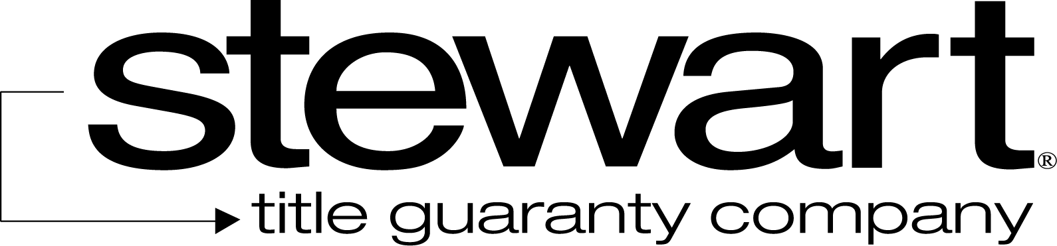

File No: | Charge:

The Company insures against loss or damage sustained by the Insured by reason of the lack of a right of access to the following utilities or services: [CHECK ALL THAT APPLY]

Water service | Natural gas service | Telephone service
Electrical power service | Sanitary sewer | Storm water drainage

either over, under or upon rights-of-way or easements for the benefit of the Land because of:
(1) a gap or gore between the boundaries of the Land and the rights-of-way or easements;
(2) a gap between the boundaries of the rights-of-way or easements ; or
(3) a termination by a grantor, or its successor, of the rights-of-way or easements.
This endorsement is issued as part of the policy. Except as it expressly states, it does not (i) modify any of the terms and provisions of the policy, (ii) modify any prior endorsements, (iii) extend the Date of Policy, or (iv) increase the Amount of Insurance. To the extent a provision of the policy or a previous endorsement is inconsistent with an express provision of this endorsement, this endorsement controls. Otherwise, this endorsement is subject to all of the terms and provisions of the policy and of any prior endorsements. This endorsement is issued on this the day of , 20 .
Signed under seal for the Company, but this endorsement is to be valid only when it bears an authorized countersignature.
Countersigned by:

_______________________________________
Authorized Countersignature

