ENDORSEMENT
ATTACHED TO POLICY NUMBER

ISSUED BY
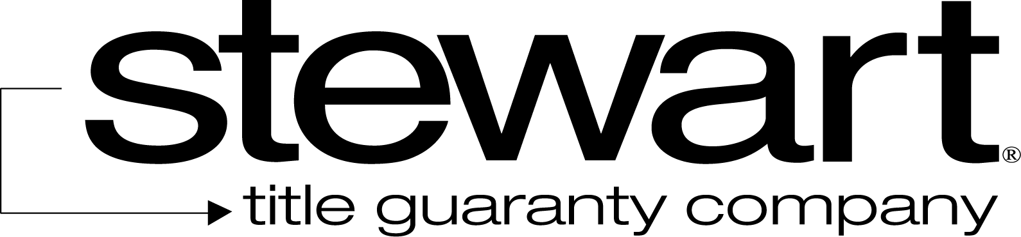

File No: | Charge:

- The Company insures against loss or damage sustained by the Insured in the event that, at Date of Policy,
  - according to applicable zoning ordinances and amendments, the Land is not classified Zone .
  - the following use or uses are not allowed under that classification:

  - There shall be no liability under paragraph 1.b. if the use or uses are not allowed as the result of any lack of compliance with any conditions, restrictions, or requirements contained in the zoning ordinances and amendments, including but not limited to the failure to secure necessary consents or authorizations as a prerequisite to the use or uses. This paragraph 1.c. does not modify or limit the coverage provided in Covered Risk 5.
- The Company further insures against loss or damage sustained by the Insured by reason of a final decree of a court of competent jurisdiction either prohibiting the use of the Land, with any existing structure, as insured in paragraph 1.b. or requiring the removal or alteration of the structure; because, at Date of Policy, the zoning ordinances and amendments have been violated with respect to any of the following matters:
  - Area, width, or depth of the Land as a building site for the structure
  - Floor space area of the structure
  - Setback of the structure from the property lines of the Land
  - Height of the structure, or
  - Number of parking spaces.
- There shall be no liability under this endorsement based on
  - the invalidity of the zoning ordinances and amendments until after a final decree of a court of competent jurisdiction adjudicating the invalidity, the effect of which is to prohibit the use or uses;
  - the refusal of any person to purchase, lease or lend money on the Title covered by this policy.
This endorsement is issued as part of the policy. Except as it expressly states, it does not (i) modify any of the terms and provisions of the policy, (ii) modify any prior endorsements, (iii) extend the Date of Policy, or (iv) increase the Amount of Insurance. To the extent a provision of the policy or a previous endorsement is inconsistent with an express provision of this endorsement, this endorsement controls. Otherwise, this endorsement is subject to all of the terms and provisions of the policy and of any prior endorsements. This endorsement is issued on this the day of , 20 .
Signed under seal for the Company, but this endorsement is to be valid only when it bears an authorized countersignature.
Countersigned by:

________________________________________
Authorized Countersignature

