ENDORSEMENT
ATTACHED TO POLICY NUMBER

ISSUED BY
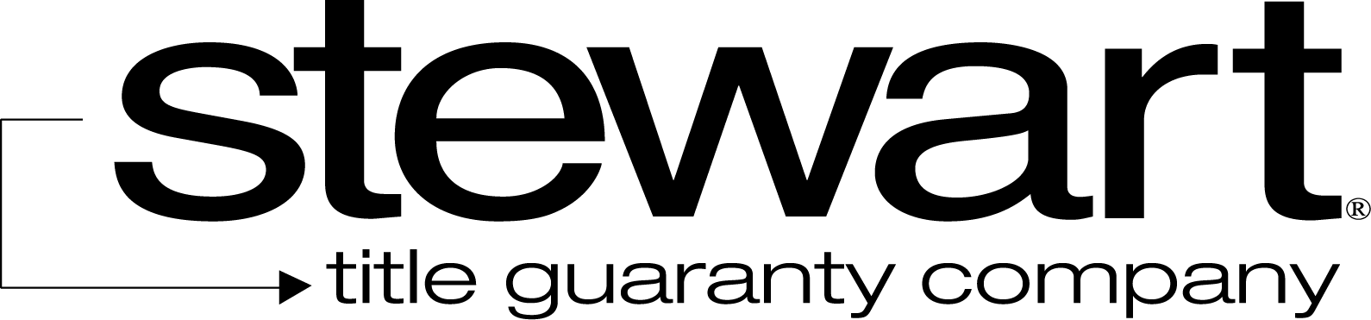

File No: | Charge:

- The Date of Coverage is amended to: .
  - The current disbursement is $ .
  - The aggregate amount, including the current disbursement, recognized by the Company as disbursed by the Insured is $ .
- Schedule A is amended as follows: None
- Schedule B is amended as follows:
  - Part I

  - Part II

This endorsement is issued as part of the policy. Except as it expressly states, it does not (i) modify any of the terms and provisions of the policy, (ii) modify any prior endorsements, (iii) extend the Date of Policy, or (iv) increase the Amount of Insurance. To the extent a provision of the policy or a previous endorsement is inconsistent with an express provision of this endorsement, this endorsement controls. Otherwise, this endorsement is subject to all of the terms and provisions of the policy and of any prior endorsements. This endorsement is issued on this the day of , 20 .
Signed under seal for the Company, but this endorsement is to be valid only when it bears an authorized countersignature.
Countersigned by:  ______________________________  Authorized Countersignature |  | 