

ALTA 26 SUBDIVISION ENDORSEMENT (07-01-2021)
THIS ENDORSEMENT IS ISSUED AS PART OF POLICY NUMBER

ISSUED BY
STEWART TITLE GUARANTY COMPANY

File No.: | Charge:

The Company insures against loss or damage sustained by the Insured by reason of the failure of the Land to constitute a lawfully created parcel according to the State subdivision statutes and the subdivision ordinances of the county or municipality of the State applicable to the Land.

This endorsement is issued as part of the policy. Except as it expressly states, it does not (i) modify any of the terms and provisions of the policy, (ii) modify any prior endorsements, (iii) extend the Date of Policy, or (iv) increase the Amount of Insurance. To the extent a provision of the policy or a previous endorsement is inconsistent with an express provision of this endorsement, this endorsement controls. Otherwise, this endorsement is subject to all of the terms and provisions of the policy and of any prior endorsements.

Date:

 |  | 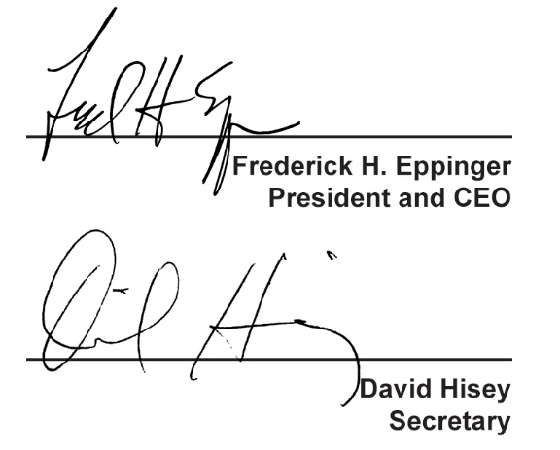
  Countersigned by:
  ___________________________________
  Authorized Countersignature

