

ALTA 3 ZONING ENDORSEMENT (07-01-2021)
THIS ENDORSEMENT IS ISSUED AS PART OF POLICY NUMBER

ISSUED BY
STEWART TITLE GUARANTY COMPANY

File No.: | Charge:

1. For purposes of this endorsement, “Zoning Ordinance” means a zoning ordinance or zoning regulation of a political subdivision of the State that is in effect and applicable to the Land at the Date of Policy.

2. The Company insures against loss or damage sustained by the Insured in the event that, at the Date of Policy:
a. According to the Zoning Ordinance, the Land is not classified Zone
b. The following use or uses are not allowed under that classification:

3. There is no liability under this endorsement based on:
a. The lack of compliance with any condition, restriction, or requirement contained in the Zoning Ordinance, including but not limited to the failure to secure necessary consents or authorizations as a prerequisite to the use or uses. Section 3.a. does not modify or limit the coverage provided in Covered Risk 5.
b. The invalidity of the Zoning Ordinance until after a final decree of a State or federal court having jurisdiction adjudicating the invalidity, the effect of which is to prohibit the use or uses described in Section 2.b.
c. The refusal of any person to purchase, lease, or lend money on the Title covered by this policy.

This endorsement is issued as part of the policy. Except as it expressly states, it does not (i) modify any of the terms and provisions of the policy, (ii) modify any prior endorsements, (iii) extend the Date of Policy, or (iv) increase the Amount of Insurance. To the extent a provision of the policy or a previous endorsement is inconsistent with an express provision of this endorsement, this endorsement controls. Otherwise, this endorsement is subject to all of the terms and provisions of the policy and of any prior endorsements.

Date:

Countersigned by: |  | 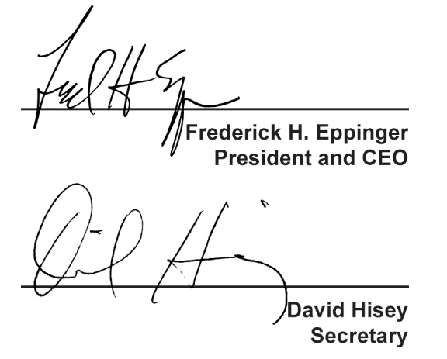
  ___________________________________
  Authorized Countersignature
For purposes of this form the “Stewart Title” logo featured above is the represented logo for the underwriter, Stewart Title Guaranty Company.

