

ALTA ENDORSEMENT 3.2-06 (ZONING – LAND UNDER DEVELOPMENT)
ATTACHED TO POLICY NUMBER

ISSUED BY
STEWART TITLE GUARANTY COMPANY

File No.: | Charge:

- For purposes of this endorsement:
  - "Improvement" means a building, structure, road, walkway, driveway, curb, subsurface utility or water well existing at Date of Policy or to be built or constructed according to the Plans that is or will be located on the Land, but excluding crops, landscaping, lawns, shrubbery, or trees.
  - “Plans” mean those site and elevation plans made by dated last revised , designated as consisting of sheets.
- The Company insures against loss or damage sustained by the Insured in the event that, at Date of Policy,
  - according to applicable zoning ordinances and amendments, the Land is not classified Zone
  - the following use or uses are not allowed under that classification:
  - There shall be no liability under paragraph 2.b. if the use or uses are not allowed as the result of any lack of compliance with any condition, restriction, or requirement contained in the zoning ordinances and amendments, including but not limited to the failure to secure necessary consents or authorizations as a prerequisite to the use or uses. This paragraph 2.c. does not modify or limit the coverage provided in Covered Risk 5.
- The Company further insures against loss or damage sustained by the Insured by reason of a final decree of a court of competent jurisdiction either prohibiting the use of the Land, with any Improvement as specified in paragraph 2.b. or requiring the removal or alteration of the Improvement, because of a violation of the zoning ordinances and amendments in effect at Date of Policy with respect to any of the following matters:
  - Area, width, or depth of the Land as a building site for the Improvement
  - Floor space area of the Improvement
  - Setback of the Improvement from the property lines of the Land
  - Height of the Improvement, or
  - Number of parking spaces.
- There shall be no liability under this endorsement based on:
  - the invalidity of the zoning ordinances and amendments until after a final decree of a court of competent jurisdiction adjudicating the invalidity, the effect of which is to prohibit the use or uses;
  - the refusal of any person to purchase, lease or lend money on the Title covered by this policy.

This endorsement is issued as part of the policy. Except as it expressly states, it does not (i) modify any of the terms and provisions of the policy, (ii) modify any prior endorsements, (iii) extend the Date of Policy, or (iv) increase the Amount of Insurance. To the extent a provision of the policy or a previous endorsement is inconsistent with an express provision of this endorsement, this endorsement controls. Otherwise, this endorsement is subject to all of the terms and provisions of the policy and of any prior endorsements. This endorsement issued on the day of , 20 .

 |  | 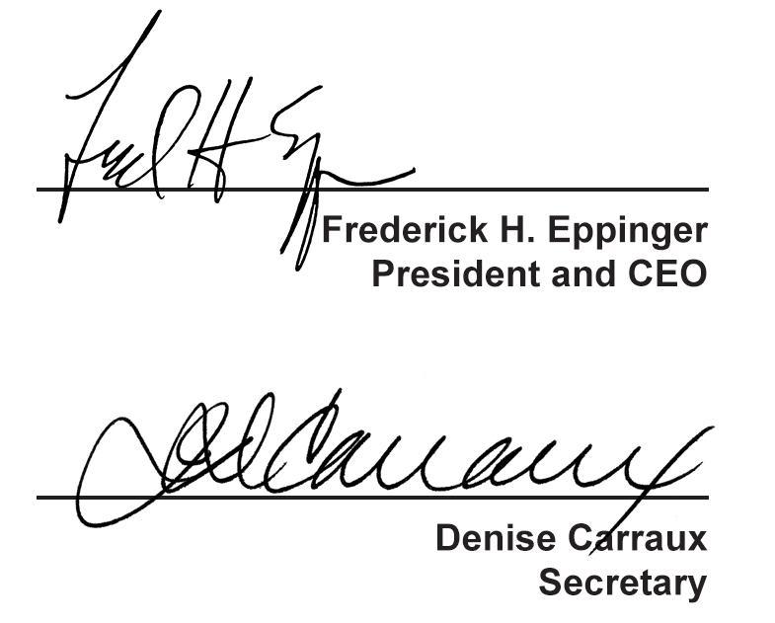
  Countersigned by:
  Authorized Countersignature
  Issuing Agency
  City State Zip
For purposes of this form the “Stewart Title” logo featured above is the represented logo for the underwriter, Stewart Title Guaranty Company.

