ENDORSEMENT
ATTACHED TO POLICY NUMBER

ISSUED BY
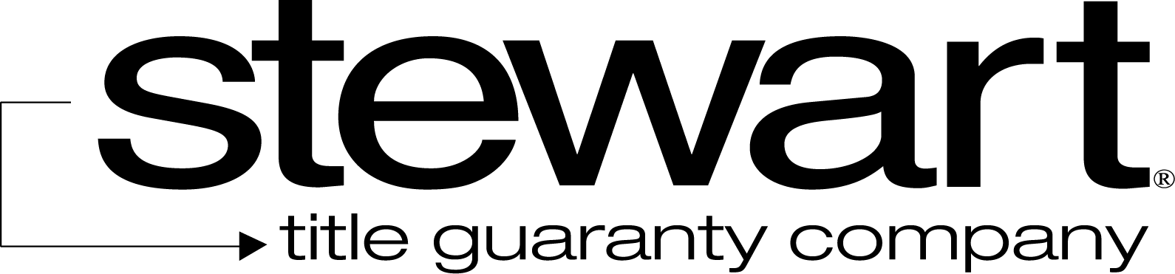

File No: | Charge:
The Company insures against loss or damage sustained by the Insured if, at Date of Policy (i) the Land does not abut and have both actual vehicular and pedestrian access to and from (the “Street”), (ii) the Street is not physically open and publicly maintained, or (iii) the Insured has no right to use existing curb cuts or entries along that portion of the Street abutting the Land.

This endorsement is issued as part of the policy. Except as it expressly states, it does not (i) modify any of the terms and provisions of the policy, (ii) modify any prior endorsements, (iii) extend the Date of Policy, or (iv) increase the Amount of Insurance. To the extent a provision of the policy or a previous endorsement is inconsistent with an express provision of this endorsement, this endorsement controls. Otherwise, this endorsement is subject to all of the terms and provisions of the policy and of any prior endorsements. This endorsement is issued on this the day of , 20 .
Signed under seal for the Company, but this endorsement is to be valid only when it bears an authorized countersignature.
Countersigned by:

________________________________________
Authorized Countersignature

