ENDORSEMENT
ATTACHED TO POLICY NUMBER

ISSUED BY
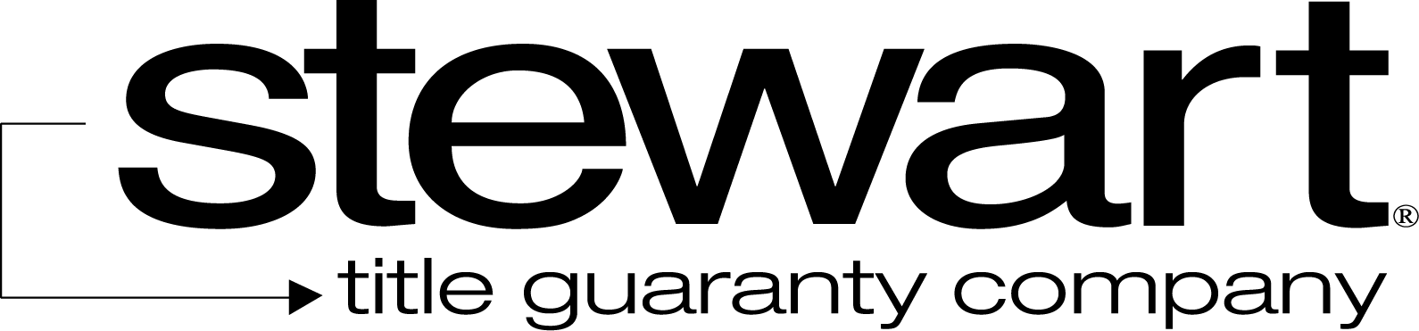

File No: | Charge:

The Company insures against loss or damage sustained by the Insured by reason of the failure of (i) a known as to be located on the Land at Date of Policy, or (ii) the map, if any, attached to this policy to correctly show the location and dimensions of the Land according to the Public Records.

This endorsement is issued as part of the policy. Except as it expressly states, it does not (i) modify any of the terms and provisions of the policy, (ii) modify any prior endorsements, (iii) extend the Date of Policy, or (iv) increase the Amount of Insurance. To the extent a provision of the policy or a previous endorsement is inconsistent with an express provision of this endorsement, this endorsement controls. Otherwise, this endorsement is subject to all of the terms and provisions of the policy and of any prior endorsements. This endorsement is issued on this the day of , 20 .

Signed under seal for the Company, but this endorsement is to be valid only when it bears an authorized countersignature.
Countersigned by:

________________________________________
Authorized Countersignature

