ENDORSEMENT
ATTACHED TO POLICY NUMBER

ISSUED BY
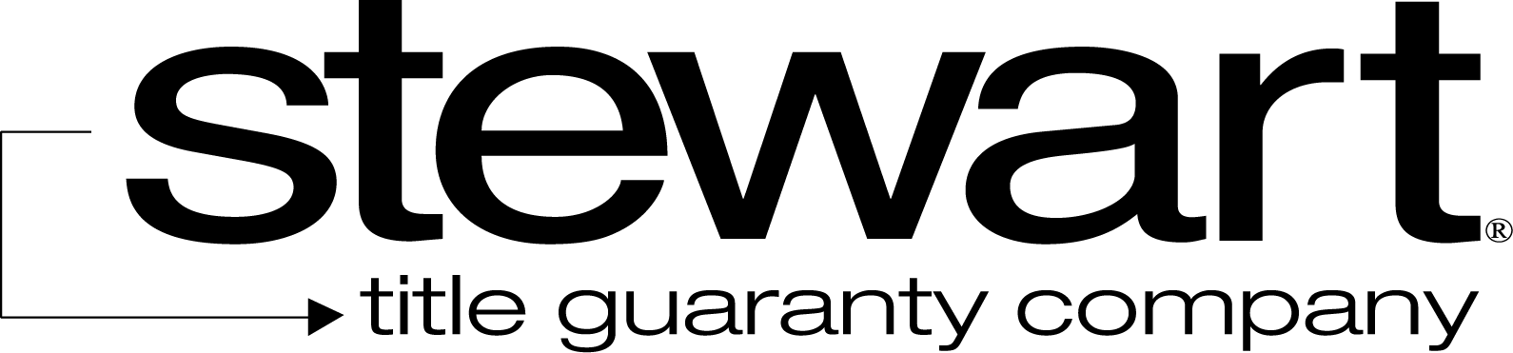

File No: | Charge:

The Company insures against loss or damage sustained by the Insured by reason of:
- The invalidity or unenforceability of the lien of the Insured Mortgage resulting from its provisions that provide for changes in the rate of interest.
- Loss of priority of the lien of the Insured Mortgage as security for the unpaid principal balance of the loan, together with interest as changed in accordance with the provisions of the Insured Mortgage, which loss of priority is caused by the changes in the rate of interest.

"Changes in the rate of interest", as used in this endorsement, shall mean only those changes in the rate of interest calculated pursuant to the formula provided in the loan documents secured by the Insured Mortgage at Date of Policy.

This endorsement does not insure against loss or damage based upon:
  - usury, or
  - any consumer credit protection or truth in lending law.

This endorsement is issued as part of the policy. Except as it expressly states, it does not (i) modify any of the terms and provisions of the policy, (ii) modify any prior endorsements, (iii) extend the Date of Policy, or (iv) increase the Amount of Insurance. To the extent a provision of the policy or a previous endorsement is inconsistent with an express provision of this endorsement, this endorsement controls. Otherwise, this endorsement is subject to all of the terms and provisions of the policy and of any prior endorsements. This endorsement is issued on this the day of , 20 .
Signed under seal for the Company, but this endorsement is to be valid only when it bears an authorized countersignature.
Countersigned by:

________________________________________
Authorized Countersignature

