ENDORSEMENT
ATTACHED TO POLICY NUMBER ____________________
ISSUED BY
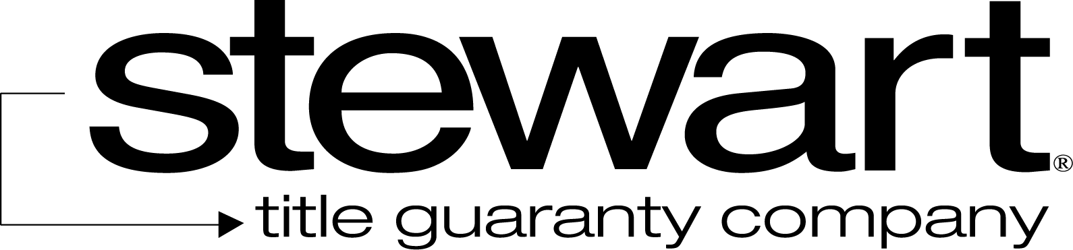

File No.: | ____________________ | Charge: ____________________

- The following policies are issued in conjunction with one another:
Policy Number | State | Amount of Insurance
- The amount of insurance available to cover the Company’s liability for loss or damage under this policy at the time of payment of loss shall be the Aggregate Amount of Insurance defined in Section 3 of this endorsement.
- The Aggregate Amount of Insurance under these policies is either:
- $ _________________; or
- If the Land is located in one of the states identified in this subsection, then the Aggregate Amount of Insurance is restricted to the amount shown below:
State | Aggregate Amount of Insurance
- Section 7(a)(i) of the Conditions of this policy is amended to read:
7. OPTIONS TO PAY OR OTHERWISE SETTLE CLAIMS; TERMINATION OF LIABILITY
In case of a claim under this policy, the Company shall have the following additional options:
- to pay or tender payment of the lesser of the value of the Title as insured or the Aggregate Amount of Insurance applicable under this policy at the date the claim was made by the Insured Claimant, or to purchase the Indebtedness.
- to pay or tender payment of the lesser of the value of the Title as insured at the date the claim was made by the Insured Claimant, or the Aggregate Amount of Insurance applicable under this policy together with any cost, attorneys’ fees, and costs and expenses incurred by the Insured Claimant that were authorized by the Company up to the time of payment or tender of payment and that the Company is obligated to pay; or

- Section 8(a) and 8(b) of the Conditions of this policy are amended to read:
8. DETERMINATION AND EXTENT OF LIABILITY
This policy is a contract of indemnity against actual monetary loss or damage sustained or incurred by the Insured Claimant who has suffered loss or damage by reason of matters insured against by this policy.
- The extent of liability of the Company for loss or damage under this policy shall not exceed the least of
- the Aggregate Amount of Insurance,
- the Indebtedness,
- the difference between the value of the Title as insured and the value of the Title subject to the risk insured against by this policy, or
- if a government agency or instrumentality is the Insured Claimant, the amount it paid in the acquisition of the Title or the Insured Mortgage in satisfaction of its insurance contract or guaranty.
- If the Company pursues its rights under Section 5 of these Conditions and is unsuccessful in establishing the Title or the lien of the Insured Mortgage, as insured, the Insured Claimant shall have the right to have the loss or damage determined either as of the date the claim was made by the Insured Claimant or as the date it is settled and paid.
- Section 10 of the Conditions of this policy is amended to read:
10. REDUCTION OF INSURANCE; REDUCTION OR TERMINATION OF LIABILITY
(a) All payments under this policy, except payments made for costs, attorneys’ fees, and expenses, shall reduce the Aggregate Amount of Insurance by the amount of the payment.
(b) If this policy insures the Title to Land located in a state identified in Section 3 b. of this endorsement:
(i) all payments under this policy, except payments made for costs, attorneys’ fees, and expenses, shall reduce the Aggregate Amount of Insurance by the amount of the payment; but
(ii) a payment made for loss or damage on land insured in one of the policies identified in Section 1 on land located outside this state shall not reduce the Aggregate Amount of Insurance in Section 3 b. of this endorsement until the Aggregate Amount of Insurance in Section 3 a. is reduced below the Aggregate Amount of Insurance in Section 3 b.
(c) However, any payments made prior to the acquisition of Title as provided in Section 2 of these Conditions shall not reduce the Aggregate Amount of Insurance afforded under this endorsement except to the extent that the payments reduce the Indebtedness.
(d) The voluntary satisfaction or release of the Insured Mortgage shall terminate all liability of the Company under this policy, except as provided in Section 2 of these Conditions, but it will not reduce the Aggregate Amount of Insurance for the other policies identified in Section 1 of this endorsement.

This endorsement is issued as part of the policy. Except as it expressly states, it does not (i) modify any of the terms and provisions of the policy, (ii) modify any prior endorsements, (iii) extend the Date of Policy, or (iv) increase the Amount of Insurance. To the extent a provision of the policy or a previous endorsement is inconsistent with an express provision of this endorsement, this endorsement controls. Otherwise, this endorsement is subject to all of the terms and provisions of the policy and of any prior endorsements.
Signed under seal for the Company, but this endorsement is to be valid only when it bears an authorized countersignature.

Countersigned by:  ______________________________  Authorized Countersignature  ______________________________  Company Name  ______________________________  City, State |  | 