STG ENDORSEMENT FOR MECHANIC AND MATERIALMEN LIENS
ATTACHED TO POLICY NUMBER

ISSUED BY
STEWART TITLE GUARANTY COMPANY

File No.: | Charge:

The Company hereby insures the Insured against loss or damage which said Insured shall sustain by reason of the establishment of priority over the lien of the insured mortgage referred to in Schedule A upon the estate or interest referred to in Schedule A of any statutory lien for labor or material now having or hereafter gaining priority over the lien of the insured mortgage referred to in Schedule A.

This endorsement is issued as part of the policy. Except as it expressly states, it does not (i) modify any of the terms and provisions of the policy, (ii) modify any prior endorsements, (iii) extend the Date of Policy, or (iv) increase the Amount of Insurance. To the extent a provision of the policy or a previous endorsement is inconsistent with an express provision of this endorsement, this endorsement controls. Otherwise, this endorsement is subject to all of the terms and provisions of the policy and of any prior endorsements.

Date:

Countersigned by:  Authorized Countersignature |  | 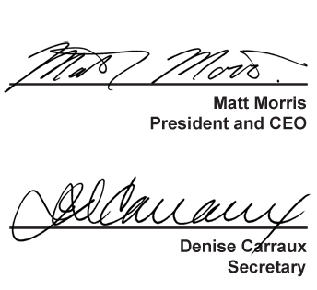
For purposes of this form the “Stewart Title” logo featured above is the represented logo for the underwriter, Stewart Title Guaranty Company.

