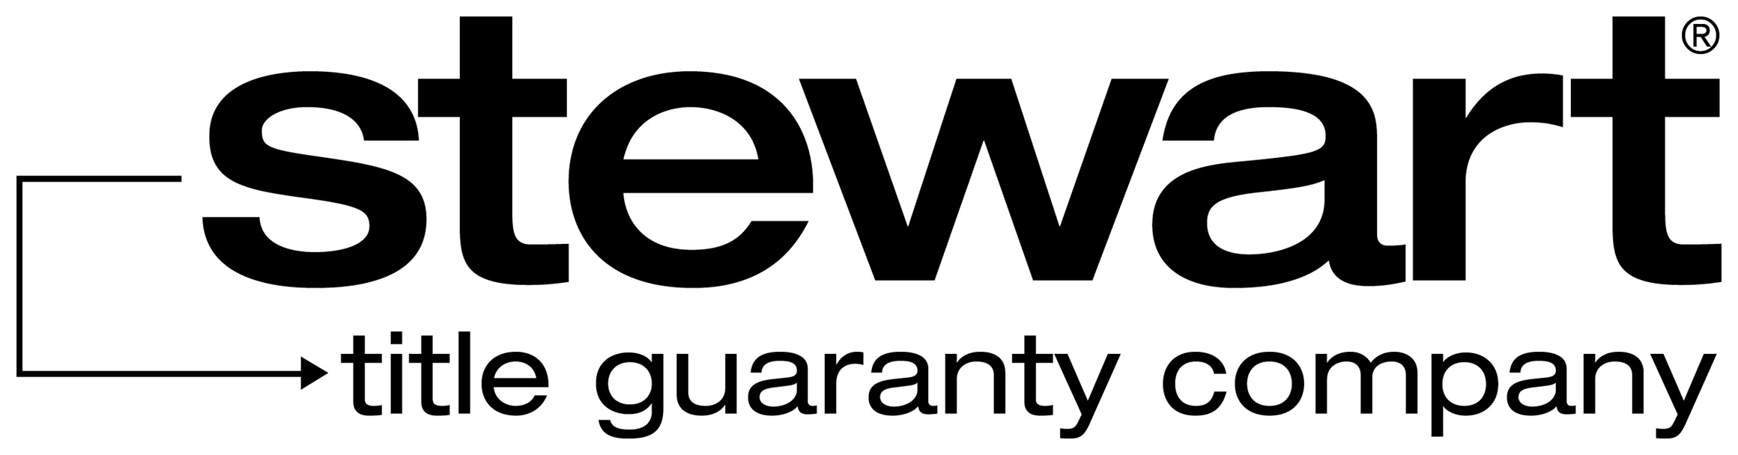 | Affidavit and Indemnity as to Debts, Liens, Possession, Encroachments and Boundary Issues

STATE OF  PARISH OF | File:

BEFORE ME, the undersigned authority, personally came and appeared:
, an authorized ___________________ of ___________________, a _______________________________ (the “Company”),
who, being first duly sworn, did depose and say that he/she has made inquiry of the appropriate persons who, in the regular course and scope of their duties for the Company have knowledge of the matters referred to herein, and as of the Effective Date of the Policy, the following are true and accurate statements of fact, except as otherwise set forth on Exhibit “A”:
- The Company owns the property (hereinafter called the “Property”) described on Exhibit “B.”
2. The Company has owned the property continuously for years, and it's possession thereof has been peaceable and undisturbed and the title to the Property has never been disrupted, nor is the Company aware of any facts by reason of which the title to, or possession of, the Property might be disputed or by reason of which any claim to the Property might be asserted adversely to the Company. A representative of the Company has inspected the property boundaries and lot lines, and to the best of the Company’s knowledge there are no improvements which encroach or extend onto the property of adjoining landowners. There are also no improvements owned by adjoining landowners which extend or encroach onto the subject property.
3. No party other than the Company is in possession of all or any portion of the Property under any oral or written leases, or otherwise, EXCEPT:

4. There are no unrecorded documents affecting title to the Property.
5. The Company, during the time of ownership of the Property, has conveyed no portion of the Property nor done any act or allowed any act to be done which has changed or could change the boundaries or the ownership of the Property.
6. For a period of at least seventy (70) days, there has been no construction, action, alteration or repairs of any structures or improvements on the Property, nor has any material been delivered to the Property.
7. There are no liens, encumbrances, or other written claims against title to the Property, except as shown on Exhibit A.
8. The Company has no knowledge of any highways, abandoned roads, lanes, cemetery or family burial grounds, springs, streams, rivers, ponds or lakes bordering or running through the Property.
9. There are no due taxes or special assessments.
10. There are no improvements which encroach or extend onto any easement affecting the subject property. EXCEPT:

11. The subject property has street access to a publicly maintained road, with vehicular and pedestrian access. If access to the subject property is served by a servitude or right-of-way, this fact has been disclosed to Stewart Title Guaranty Company and its agent.
12. There is no visible activity on the subject property related to oil and/or gas (or other mineral, gravel or timber) production, including, but not limited to drilling, storage, or transmission, logging, cutting, mining, or farming.
13. The survey attached hereto, reflects the current status of the premises. The Company has not laid out or constructed any driveways, fences, additions to buildings nor added any outbuildings that are not shown on the said survey.
14. If applicable, all management fees, site assessment fees, common expense assessments and special assessments currently assessed against the premises have been paid. There is no “right of first refusal” or other restriction on the sale of the premises which has not been waived by any association or other related party.
- There are no violation of any Covenants, Conditions or Restrictions, if any, affecting the Property.
- There are no pending repairs or improvements to the street(s) adjacent to the land. There are no pending or anticipated condemnation proceedings against all or any part of the Property.
- If the Company is a seller, Affiant is not a non-resident alien, foreign corporation, foreign trust, foreign estate or other foreign entity (as defined in the Internal Revenue Code and Income Tax Regulations). The Company’s U.S. employer identification number is:. The Company’s mailing address is: .
- This Affidavit may be disclosed to the Internal Revenue Service and is furnished to Buyer to inform Buyer that withholding of tax is not required under Section 1445 of the Internal Revenue Code.
- No member/owner/officer of the Company is on the Specially Designated Nationals and Blocked Persons list of OFAC (the “SDN List”)
- The Company is not in violation of money laundering or anti-terrorism laws, Trading with the Enemy Act or any foreign asset control regulations of the United States Treasury, and that entering into the transactions enacted herewith does not cause the Company to be in violation.
21. There are no pending suits, proceedings, judgments, bankruptcies, liens, environmental liens or assessments, encumbrances or executions against the Company or against the Property, either in the parish in which the Property is situated or anywhere else in the United States.
22. If Stewart Title Guaranty Company acts as settlement agent, or if the settlement agent is acting pursuant to an insured closing agreement to which Stewart Title Guaranty Company is a party, the Company agrees that should the payoff on any mortgage(s) affecting the Property be more than the amount quoted by the lender, the Company will remit an amount equal to the overage within twenty-four (24) hours of notification by Stewart Title Guaranty Company or said settlement agent. The Company relieves Stewart Title Guaranty Company and the closing Notary from any and all responsibility as a result of the payoff quotation by said Lending institution.
This affidavit is given to induce STEWART TITLE GUARANTY COMPANY, to issue its title insurance policy or policies without exception to matters herein represented, and as an inducement therefor, the Company agrees to and hereby does indemnify and hold STEWART TITLE GUARANTY COMPANY harmless of and from any and all loss, cost, damage and expense of every kind, including attorneys fees, which STEWART TITLE GUARANTY COMPANY shall or may suffer or incur or become liable for under its said policy or policies now to be issued, or any reissue, renewal or extension thereof, directly or indirectly, as a result of any misrepresentation in this Seller's/Owner's Affidavit and Indemnity.
This affidavit is further given to induce STEWART TITLE GUARANTY COMPANY to issue its title insurance policy or policies without exception to defects, liens, encumbrances, adverse claims or other matters known to, created or suffered by the Company, first appearing in the public records or attaching subsequent to the effective date of STEWART TITLE GUARANTY COMPANY 's above referenced title insurance commitment ("Gap Matters"), and as inducement therefor, the Company agrees to and hereby does indemnify and hold STEWART TITLE GUARANTY COMPANY harmless of and from any and all loss, cost, damage and expense of every kind, including attorneys' fees, which STEWART TITLE GUARANTY COMPANY shall or may suffer or incur or become liable for under its said Policy or policies now to be issued, or any reissue, renewal or extension thereof, directly or indirectly, as a result of any Gap Matters.
AFFIANT:
___________________
By: , its ___________________

Sworn to and subscribed before me this _________ day of ______________________, 20___________.

______________________________________
Notary Public
Printed Name: ___________________________
Notary/Bar No: ___________________________

EXHIBIT “A”

EXCEPTION ITEMS

EXHIBIT “B”

LEGAL DESCRIPTION

