Reinsurance Questionnaire
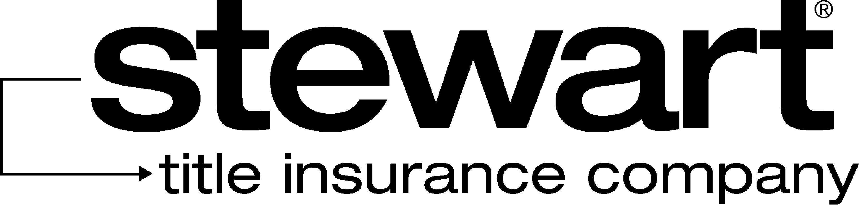

To: | Yeidy Rodriguez, Legal Assistant  Stewart Title Insurance Company  300 East 42nd Street, 10th Floor  New York, NY 10017  Ph: (212) 922-0050 Fax (646) 525-3596  Email: yrodriguez@stewart.com |  |  |  |  |  |  |  |  |  |  |  |  |  |  |  |  |  | From:
Project Name:
Address:
File No.: |  |  |  |  |  |  |  |  |  |  |  |  |  |  |  |  |  |  | Policy No.:
Enclosed Documents: |  |  |  |  |  |  |  |  |  |  |  |  | Commitments |  |  |  |  |  |  |  | Pro-Formas |  |  |  |  |  |  |  |  |  | Policies
Owners Policy: |  |  |  |  |  |  |  | Fee |  |  |  |  |  | Leasehold |  |  |  |  |  | Policy Amount:
Insuring:
Owners Policy: |  |  |  |  |  |  |  | Fee |  |  |  |  |  | Leasehold |  |  |  |  | Policy Amount:
Insuring:
Loan Policy: |  |  |  |  | Fee |  |  |  |  |  | Leasehold |  |  |  |  | Construction |  |  |  |  |  | Policy Amount:
Insuring:
Loan Policy: |  |  |  |  | Fee |  |  |  |  |  | Leasehold |  |  |  |  | Construction |  |  |  |  |  | Policy Amount:
Insuring:
Purpose of Financing (i.e. purchase, construction loan, etc.):
Co-Insurance: |  |  |  |  |  | Yes |  |  |  |  |  | No |  |  | Total Amount of Transaction:
Company: |  |  |  |  |  |  |  |  |  |  |  |  |  |  |  |  |  |  |  | Amount
Company: |  |  |  |  |  |  |  |  |  |  |  |  |  |  |  |  |  |  |  | Amount
Type/Character of Property (vacant land, residential, commercial, etc.):
Endorsements or affirmative coverage given? (list endorsements):
Are there any unusual risks:
Please list name and amount of other reinsurer, if any:
Letter Addressed to: |  |  |  |  |  |  |  |  | Yeidy Rodriguez |  |  |  |  |  |  |  | Other (if you checked other enter addressee below)
Addressee:

