


Stewart Independent Agents Program

Welcome to Office Depot! Enjoy discounted pricing through the Office Depot Program by using the below shopping methods. Shop online and/or shop in store. Choose what works best for you!

Step 1: Register

Click HERE to get started!

Next, click on the “Register” link. You will be prompted to create a profile and a password. Now you are ready to shop online!

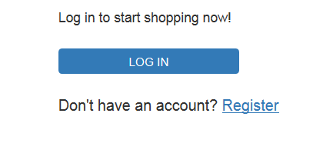

Step 2: View the Bulletin Board (first time users only)

Scroll down to find the section titled “Bulletin Board & Messages”
Click “Read More” link. Here you will find information on shopping in store & important account information.
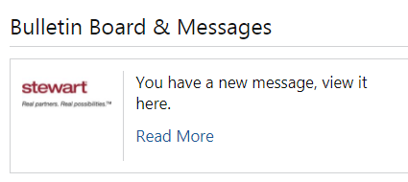

To shop in the retail stores, please follow the below instructions as noted on the bulletin board page.

Click the “register your card” button to register your personal credit card(s).
Click on the “store purchasing card” button to download and print.

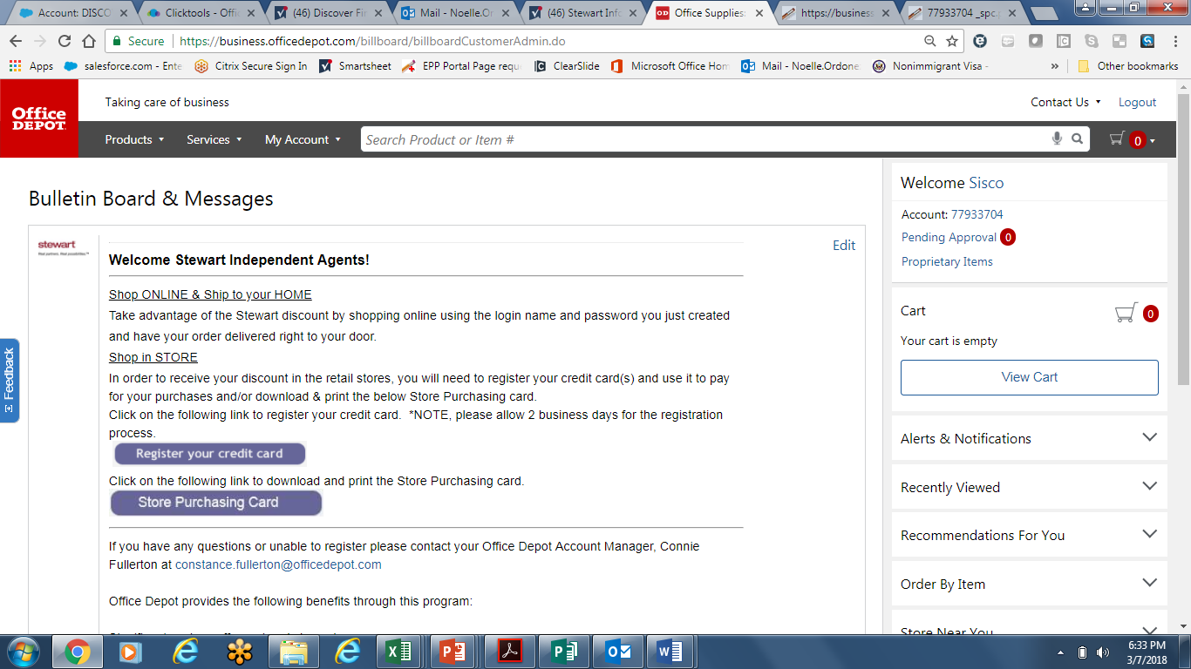

To shop online, simply add items to your card. Once ready to complete your order, go to the checkout page and enter your credit card information.

You may also save your credit card under your profile. Go to MY ACCOUNT, then MY PROFILE OVERVIEW and PAYMENT.

Please note:

If you registered your card(s), your card(s) will be ready for store purchasing in 2 business days. (Note, you will not receive an email confirmation notifying you when your card is ready to use in the store.)

When using the store purchasing card, present at the register along with a form of payment.

You do not have to identify yourself as a member of the program; simply provide your registered credit card for payment.

Once your credit card has been swiped for payment, the qualified products will be discounted if applicable. There will be no documentation showing the retail price compared to your corporate program discount price.

For agencies with a large annual spend, account billing is available. Please contact Brandi Wright for more information. Via phone at 843-868-1101 or via email at Brandi.wright@officedepot.com.

